SMARTALYZE: AN AI-ASSISTED DATA VISUALIZATION AND ANALYSIS PLATFORM


DAVAO DEL NORTE STATE COLLEGE

Institute of Computing

New Visayas, Panabo City

A Capstone Project Presented by:

ALTERADO, MAY ANTONETTE A.
ERAN, DONNA MEG S.
RAZ, GEAN

JUNE 2026

CHAPTER 1
INTRODUCTION
Background of Study
The proliferation of digital data has led to the necessity of becoming literate and competent in working with data as well as managing it effectively. Many people and organizations use data to make decisions, but making sense of raw data is not an easy task; in particular, it can be difficult for those who do not have any programming or technical knowledge [1]. Data preparation processes, such as collection, organization, transformation, and correction of data, often take a lot of time in the process of working with data, which calls for the necessity of automation of these activities [2]. Such problems became one of the reasons for the data democratization movement, where access to data and analysis tools is provided for everyone, not only information technology specialists [1].
Data cleaning and preprocessing constitute critical steps in the data analysis process since they directly affect the quality, consistency, and reliability of the analytical findings [3]. Traditional data preprocessing procedures include repetitive and time-consuming activities especially if datasets feature missing values, duplicates, inconsistent formats, etc. which should be corrected manually [4]. These facts have contributed to the emergence of automated data cleaning and preprocessing solutions that simplify the data preparation process and make the data transformation process transparent and easy-to-understand [5].
Automated data preprocessing systems have been created to decrease time and effort needed to prepare the datasets for analysis. For example, Auto-Prep enables users to perform common preprocessing activities including data types identification, missing values handling, encoding categorial variables, scaling features, attributes selection, and data preparation for machine learning algorithms [6]. However, even automated cleaning requires manual validation of certain decisions of the system, especially if the latter cannot estimate whether the chosen approach is the best one. To solve this problem, Cleenex suggests involving users into the iterative process of data cleaning when users review and validate suggested corrections [7]. More recently, such a framework as AutoMind has explored the possibility of using the knowledge of experts and large language and model agents for supporting different phases of automated data science including solution exploration and coding based on task complexity [8].
The United Kingdom has advanced the agenda of wider and more responsible data use with the National Data Strategy focused on enhancing data access, data skills, innovation, and data usage in government and public services [9]. Also, Singapore's National AI Strategy 2.0 encourages the responsible adoption of artificial intelligence in order to improve public services, strengthen the economy and empower individuals and companies [10]. Both initiatives indicate the governmental interest in improving data access, digital skills, and responsible use of technologies in order to improve services and decision making. This direction is relevant to the Smartalyze project as it will provide non-technical users with the means of preparing, analyzing, and interpreting structured datasets.
In the Philippines, the Philippine Development Plan 2023-2028 focuses on digital transformation, innovations, and the development of skills required for the participation of Filipinos in a technologically-based economy [11]. In addition, the DOST Harmonized National Research and Development Agenda 2022-2028 serves as the guidance document for the prioritization of the research agenda of the country and development of science- and technology-based solutions for addressing the national and sectoral needs [12]. Moreover, the E-Governance Act regulates the shift of government services and processes towards integrated digital environment and strengthens ICT literacy and competency development programs [13]. All the mentioned directions are relevant to the Smartalyze project as it will provide students, researchers, educators, and small business owners with accessible tools for preparing, analyzing, visualizing, and interpreting structured datasets.
At Davao del Norte State College, research includes the collecting, organizing, and analyzing of data in various fields of academic discipline. The College has publications on information technology and other disciplines employing data-oriented approaches including data mining, geographic information systems, sentiment analysis, and information systems [14]. Furthermore, the College continues supporting and evaluating research and extension projects, including the ones from the Information Technology and Systems cluster [15]. All these facts indicate the increasing role of data management and analysis in the college. In this regard, Smartalyze will provide students, researchers, educators, and other non-technical users with the accessible platform for cleaning, analyzing, visualizing, and interpreting structured data.
The development of Smartalyze project will contribute to the achievement of Sustainable Development Goal 4 that is concerned with inclusive and equitable quality education and lifelong learning opportunities for all as it will provide students, researchers, educators, and other users with the means of developing their skills in data preparation, analysis, and interpretation [16]. Also, it will contribute to Sustainable Development Goal 9 that is focused on innovation and infrastructure by developing Smartalyze as an accessible AI-assisted platform for cleaning, analyzing, visualizing, and interpreting structured datasets [17]. Moreover, the proposed platform will be consistent with the Davao del Norte State College Research, Development, and Extension Agenda for 2026-2030 which guides the priorities of research activities and extension of the College [18]. Being a project developed by students of the Institute of Computing, Smartalyze will provide a local solution aimed at increasing accessibility of common data-preparation and basic analysis tasks among the DNSC community.
In order to address the mentioned challenges, Smartalyze will be developed as an AI-assisted, web-based data cleaning and basic analysis platform aimed at assisting users in preparing, analyzing, visualizing, and interpreting structured datasets with the help of guided recommendations, rule-based preprocessing, and basic machine learning approaches.
Objectives of the Study
The primary goal of the current research is to design and develop Smartalyze, an innovative AI-assisted platform for web-based data-cleaning and basic analysis.
More specifically, the following objectives have been set to meet the above-mentioned goal:
- Design and develop a web-based data-ingestion module that will allow the users to import structured datasets in such formats as CSV, Excel, and JSON and image-based documents (PNG, JPG) containing tabular data for data-extraction purposes.
- Evaluate and compare three different Large Language Model choices to create well-understood and explained outputs from the processes of data cleaning, statistical analysis, and visualization. Implement Groq as the chosen Large Language Model inference provider for Smartalyze, based on its quick generation response, fast cloud-based inference, easy API integration, low resource consumption locally, and suitable for giving AI-supported explanations via the web interface.
- Design an automated data-cleaning module that will use rule-based methods to solve data quality problems in such a way as:
  - imputation or elimination of missing values,
  - detection and removal of duplicates, and
  - standardization of data types.
- Implement intelligent machine learning techniques that would give recommendations about data structuring, grouping, summarization, and trending.
- Develop an interactive visualization dashboard that would present summarized information about data trends and patterns visually.
- Develop a data export module that will enable the user to download the cleaned and processed datasets in such formats as CSV, Excel, and JSON.
Significance of the Study
Smartalyze will be developed as an AI-assisted, Web-based platform which facilitates users to clean, visualize and perform basic analysis on datasets, which will help the users in better understanding of their data without being technically proficient. This research is going to benefit several individuals who have not been using such tools due to lack of skills to do that, such as:
Students. With Smartalyze, students will be able to easily prepare, clean, visualize and analyze datasets for academic purposes and any research activity that they conduct. They would get relief from manually performing data preprocessing tasks and at the same time be able to understand the pattern and trend in the data without being required to know programming and data analysis skills.
Small Business Owners. Small Business Owners would be able to upload operational datasets like sales data, inventory data and financial data in order to gain summarized insight about the business information through Smartalyze.
Researchers and Educators. This tool can serve as a practical tool for both teaching and learning of data preparation and basic data analysis. Researchers would be able to easily organize and preprocess their datasets while educators can show the process of data cleaning, visualization and basic data analysis concepts.
Future Developers and Researchers. This research is going to lay a solid foundation for future developers and researchers to further enhance the platform by adding advanced data analysis and prediction techniques along with other data processing and visualization techniques.
Scope and Limitation
This research will cover development and testing of Smartalyze, the AI-assisted web-based tool that will help to prepare, visualize, and analyze structured datasets for those users who do not have technical background. It will support multiple accounts of the registered users to store their uploaded files and results of the work.
Smartalyze will be able to process structured data in CSV, Microsoft Excel (.xlsx and xls), and JSON format. It will also enable uploading of the tabulated images stored in PNG and JPG formats via Optical Character Recognition technology. Prior to starting the processing, the system will check if the uploaded file is readable and organized into a proper table structure.
Basic functions of file management will be supported by the platform. Users will be able to upload, rename, modify, organize, and delete files. Moreover, he/she will be able to create drafts to continue working on them later. During preparation of the dataset, it will be possible to add, rename, or delete columns in the dataset.
Data cleaning will be performed via detection of common problems related to missing values, duplicated rows, and inconsistent data type via rules-based approach. Suggested values will be provided if there are any dependencies between fields. For example, if there is a value of city in the dataset, the system will suggest ZIP code for the particular field. It will not be applied automatically and will still need approval from the user.
Once the dataset has been prepared, Smartalyze will offer standard analytical tools such as descriptive statistics, grouping, summarization, linear regression for trend detection, and interquartile range-based anomaly detection. Moreover, the system will create charts, tables, and AI-explanations to help the user interpret the obtained results. The progress bar will be used when the data is being analyzed. Additionally, the user will be able to download prepared datasets and analytical results in formats supported by the platform.
As for the scope of the study, it will cover structured datasets and images that contain tabular information. The system will be aimed at analyzing structured data and will not support audio, video, handwritten data, large amounts of unstructured documents, and other types of content. The quality of optical character recognition will depend on several factors including the quality of an image, its lighting, and the readability of the source information.
The suggestions concerning missing values will depend on the information contained in the dataset and relations between the variables. As a result, the suggested values will not always be accurate and should be reviewed by the user. The same concerns the explanations and analytical outputs generated by the system. They should be considered only as a support tool.
The visualization capabilities will be limited to the types of charts and tables offered by the platform. Smartalyze will not have a business intelligence dashboard, real-time analytics, and other advanced tools such as predictive analysis. The file size of the uploaded datasets will be limited by the file size limitation of the platform.
Review of Related Literature and Works

Related Literature
Due to the growing size and complexity of digital data, it becomes increasingly essential to ensure the existence of robust data preparation approaches. There are a number of problems associated with data analysis, including missing values, inconsistencies, noise, and data incompatibility that can influence the reliability of obtained results [19]. Moreover, there have been recent investigations of automated and domain-specific machine-learning platforms aimed at reducing manual input and specialized skills needed for data preparation and analysis [20]. The following section considers concepts, systems, and open questions related to the creation of Smartalyze.

1. Data Analytics and Data-Driven Decision Making
Data analytics is the tool which can help educational institutions, businesses, and other organizations in transforming collected data into information that would serve as a basis for planning, evaluation, and decision making. In order to make sure that data can lead to any actions, it has to be put into a proper context and made accessible to people who need it [21]. However, data preparation, analysis, and interpretation may require some technical skills and experience with specific data analysis tools.
Data democratization has been suggested as the way of widening the access to data and analytics for both technical and non-technical users [22]. It implies removing various obstacles that impede the process of data exploration, analysis, and sharing in the organization [23]. The concept of self-service analytics and data literacy is mentioned in the literature in relation to the facilitation of data understanding and participation in data-informed activities [22]. The ideas of data democratization, self-service analytics, and data literacy are related to Smartalyze, which is designed to provide basic guidance in data cleaning and analysis as well as data visualization for the users who do not possess advanced programming skills.

2. Data Cleaning and Data Preprocessing
Cleaning and preprocessing of data is required before it can be used for further analysis. Raw data usually include such errors as missing values, duplicates, formatting errors, wrong data types, among others, that might impact the validity of the results. Recent benchmarking of available data-cleaning and preprocessing solutions revealed the variability in accuracy, processing time, memory usage, usability, scalability and ability to scale to handle larger data volumes [24]. The choice and design of cleaning procedures is thus likely to have an impact on the quality of the processed dataset and efficiency of the whole workflow.
Other researchers attempted to combine automatic data cleaning with the guidance from users. BoostClean offers different combinations of approaches to detect and fix data errors that increase the quality of datasets for machine learning [25]. ActiveClean provides a procedure that combines iterative data cleaning and training of statistical models and allows users to incrementally clean the data set and see its effect on the model [26].
These examples show that automation helps to minimize repetitive cleaning procedures, however, user interaction becomes essential for changes that depend on the interpretation of the dataset. In particular, Smartalyze will rely on the identification of typical data quality problems including missing values, duplicates, incorrect data types, excessive white spaces, different capitalizations, wrong date formats, etc. Proposed fixes will be presented to users before applying any changes.
3. Missing Data Handling Techniques
Missing values are the most commonly seen problems in structured datasets. Incomplete data can influence the process of summarizing, visualizing, performing statistical operations, and interpreting the analysis results. As shown in research, data cleaning might use various techniques and include different processes such as detection and correction of errors based on rules, statistical methods, and machine learning algorithms [27]. The proper technique to apply depends on the type of variable, the volume of incomplete information, and relationships between existing attributes.
Several automated techniques have been developed for different types of datasets. CleanTS is a tool created specifically for automatic cleaning of univariate time-series datasets, and it includes procedures of processing missing values, detection of anomalies, and presentation of time-series data at various granularities [28]. However, since this tool has been created for a certain type of dataset, some techniques that it uses may be unsuitable for all types of structured data.
Smartalyze will use a guided procedure for processing missing data. This system will be able to detect incomplete values and provide recommendations of what values can be used for filling the gaps if there are certain relationships between existing attributes in the uploaded dataset. For instance, if there is a certain value related to some records belonging to a certain category, Smartalyze will recommend filling incomplete values with that value.
4. Automated Data Structuring and Summarization
Data set preparation is not only about fixing the errors individually. It requires organizing the data into a consistent format that could later be grouped, summarized, visualized or analyzed. Wang and Strong argued that evaluating data quality is not about accuracy only since its usefulness is also determined by criteria like relevance, completeness, understandability, appropriate presentation and accessibility [29]. Hence, the participation of users who understand the purpose and context of the dataset in checking the data set preparation should continue.
Similarly, holistic data cleaning approaches suggest that data quality problems should be investigated considering the other data entries, rules and dependencies rather than as independent errors [30]. This is important for Smartalyze since there is a certain relationship between the value in one field and the information in the other attribute or record.
Smartalyze will implement the findings by providing users with an ability to check and edit cell values, organize columns, generate summaries of the processed data. The recommendations made during cleaning will be reviewed and applied by the user. Moreover, the processed data will be presented using tables, visualizations and AI-powered explanations for the users who have no experience in coding and data analysis.
Overall, the reviewed literature demonstrates that automation of cleaning and structuring processes can help to speed up the data preparation process. Yet, the results' reliability is highly dependent on the initial data quality and participation of people who know the meaning of the dataset. Therefore, Smartalyze will implement automated issue detection and recommendations with the help of users, data editing, basic analysis and visualization in one web-based solution.
5. Optical Character Recognition (OCR) for Data Extraction
Optical Character Recognition (OCR) is technology that recognizes text written in scanned documents or in digital images. Today, this approach became quite popular since it facilitates data management by eliminating the need for manual encoding and transforming the information stored in physical documents into electronic form. As OCR technologies keep evolving, they become more advanced and capable of recognizing text from documents that have various layouts, fonts, and image qualities which makes them applicable in various educational, medical, business, and governmental spheres [31].
In recent times, OCR capabilities went beyond mere text recognition as document layout analysis and table structure detection were added to it. Such features enable OCR technologies to recognize rows, columns, and relationships between cells prior to the extraction of their contents. It was shown in a research devoted to the extraction of information from the scanned laboratory reports that the combination of the modern algorithms of table detection and deep learning-based OCR models increased the precision of information extraction greatly due to the complexity of document layout and poor quality scans [32].
Currently, modern OCR frameworks are also becoming more complete for practical application. For instance, PaddleOCR combines such features as text detection, text recognition, layout analysis, and table recognition within one framework. Thus, it provides better capabilities for the processing of structured documents [33].
The feature of structured information extraction from images is relevant to Smartalyze as users may have datasets in the form of photos or scanned tables rather than in the form of editable spreadsheets. In this regard, Smartalyze will use OCR to detect text from the images of supported formats, PNG and JPG, and create the dataset from the information extracted when the tabular structure is recognizable. Given that the accuracy of OCR may depend on the quality of images, their orientation, text size, and complex table structure, users will have an opportunity to review and edit the extracted information before data cleaning, preprocessing, visualization, and analysis.
6. Descriptive Statistics and Data Visualization
Descriptive statistics describe the key features of a particular dataset providing an overview of the data distribution before further analyses can be conducted. Some commonly used descriptive statistics include the mean, median, mode, frequency, minimum value, maximum value, and standard deviation, helping users to identify the central tendency and variability of numerical data. Descriptive statistics allow the users to find out about the general pattern in the dataset and make comparisons as well as notice unusual data [34].
Another important step in exploring and understanding the dataset is data visualization. Contrary to descriptive statistics, data visualization represents the dataset in graphical form making it easier to perceive. In addition to the numbers, charts, graphs, and dashboards enable users to recognize patterns in the dataset, compare and find relationships in the dataset. A recent systematic mapping study highlighted the fact that visualization-based data exploration enables non-expert users to understand a complex dataset better provided that visualization was made taking into account the aspects of usability and user engagement [35].
Moreover, the effectiveness of visualization depends on the choice of appropriate visualization for the type of data that is being processed. Recently, some research has stated that in order to be efficient, dashboards should display information in an organized form, with the use of text, charts, and interactivity guiding the user towards interpretation of data rather than showing much information without context [36].
It was also shown that interactive dashboards and visual analytics are efficient means to improve the data interpretation process for the users with non-technical background. In particular, research has found that users can understand the meaning of the data better and apply analytical results to the decision-making process in case visualizations are simple and relevant for the task at hand [37].
This idea is embodied in Smartalyze in terms of generating descriptive statistics and visual representations of the dataset after the data-cleaning process is complete. The system will generate descriptive statistics and present the dataset through charts and tables. This will enable users to analyze their datasets more efficiently.
7. Linear Regression for Trend Analysis
Linear regression is a statistical approach that is applied to identify the correlation between outcome variables and independent predictor variables. Linear regression uses the straight line to show the correlation between variables. The slope shows direction and intensity of relationship whereas the intercept demonstrates the expected value of the outcome variable at zero of the predictor variable. The coefficient of determination, which is denoted by R², may be used to describe the proportion of variation of the outcome that is explained by the fitted line [38].
Linear regression is popular because the interpretation of its results is not complicated. The positive slope means that the increasing value of the predictor variable leads to an increasing outcome. The negative slope means a decreasing tendency. However, regression results need to be analyzed carefully as a statistical association cannot be regarded as the proof of cause and effect.
The application of the method is possible only in case the relationship between the selected numerical variables is linear enough. Its applicability depends on assumptions about the independence of observations, distribution and behavior of residuals, homogeneity of variance. Outliers, unsuitable variables, the application of the linear model for the nonlinear pattern may distort the results. Predictions that were performed outside the original range should be analyzed carefully [39].
Smartalyze will implement linear regression as the base function of analysis of selected trends and relationship between selected numerical attributes. The tool will provide a user with a trend line and the related values to analyze whether the selected variables move in the same direction or the opposite one. The output will be an instrument for analysis rather than the proof of causation or prediction.
8. Interquartile Range (IQR) for Anomaly Detection
Another important stage in the process of data preprocessing is an anomaly detection. Extreme or anomalous values may distort the result of calculation of statistics. As a measure of data spread, Interquartile range (IQR) is often used to measure the spread of the middle half of the data, i.e. the difference between the first (Q₁) and the third (Q₃) quartiles of the dataset. The values lying under Q₁ − 1.5(IQR) and over Q₃ + 1.5(IQR) can be viewed as potential outliers [40].
Since IQR does not depend on the mean of the data but uses quartiles instead, it is less sensitive to outliers in comparison with other measures of dispersion like variance or standard deviation. It means that the IQR could be used for the detection of potential anomalies in a numerically valued dataset especially if the values are unevenly distributed. At the same time, results of the IQR analysis may differ depending on the features of the particular dataset.
However, using the IQR method it is impossible to find out whether the potential outlier is a false value. Therefore, some detected values that might be considered outliers are valid observations that need to be kept in the dataset. Outlier detection should be seen only as an assistance tool in data examination and not as a basis for automatic deletion of some records. This decision depends on the purpose, source, and context of the particular dataset.
Smartalyze will use the IQR method to detect potential anomalies in the selected numerical attributes. Detected values will not be deleted automatically, but will be highlighted. Then the user will decide what should be done with each record.
9. Artificial Intelligence-Assisted Explanations in Data Analysis
AI has become common in data-analysis software systems where it has been used to aid users in understanding the analytical outcomes and present results in an understandable format. Instead of replacing human judgment, human-centered AI systems are designed to aid users by providing clear information and giving them the chance to go through the outputs of the systems before taking any action [41].
Transparency and control by the user are some of the key factors that have to be considered in AI-assisted systems. The user needs to be aware of the source and limitations of the system outputs instead of getting recommendations that are provided without any adequate background information. Therefore, it is necessary that the human-centered AI focuses on making users accountable for reviewing, analyzing and determining whether to follow the information provided by the system [42].
Though AI assistance can simplify the explanation of analytical outputs, these explanations cannot be regarded as final decisions. The success of these explanations will depend on the quality of the dataset used and the analytical methods employed by the system. They have to be viewed as supporting evidence that will complement the interpretation by the human user.
Through its AI-assisted explanation feature, Smartalyze will be able to use the above guidelines. The system will give clear explanations of the selected summaries, trends, and anomalies after the process of data cleaning and basic analysis. This explanation will be meant to help the users in understanding the results but not replace the interpretation of the dataset by the user.
10. Relationship-Based Recommendations in Data Cleaning
The quality of the dataset not only relies on the validity of its values but also on the consistency of relationships between related attributes. When preparing a dataset, the information present in one field might provide hints about a value in another field. Research on data cleaning has suggested that discovery of dependencies and recurring associations between attributes could aid in detecting inconsistencies and incompleteness in the dataset [43].
Context-aware methods of data cleaning also look into records, rules, and dependencies between attributes rather than treating each value separately. Using context information, the system can detect if a certain value does not comply with recurring patterns in other related records [30].
Even though recommendations about values based on their relationships might assist users while preparing the dataset, they cannot replace the judgment of the user. Their value is defined by the completeness, consistency, and accuracy of the initial dataset. Therefore, recommendations have to be provided as supplementary information that the user can check before implementing it [27].
Smartalyze will use this approach using Relationship-Based Recommendations. It will consider recurring associations between values in related columns of the dataset and suggest a possible value if a consistent pattern was discovered. For instance, if there were many records in the same category having the same value in the related column, Smartalyze will suggest this value as a recommendation for an incomplete record. Each recommendation will be editable and have to be approved by the user.
11. Comparison of Large Language Model Providers for AI-Assisted Explanations
The language model could be integrated into the application software to convert structured data into natural language responses. In Smartalyze, the language model will not carry out data cleaning, anomaly detection, regression, or statistics. They will stay a part of the program operations of the system. The language model will receive selected results and structured prompts and generate simple explanations that will be easy to understand for non-tech-savvy users.
The Ollama, Groq, and Gemini were considered as possible language models providers for this function. All of them are capable of producing text-based explanations; however, there are differences in their accessibility, computing power, Internet dependence, and impact on the operation of Smartalyze. Comparison of these language models will help us to identify the most suitable one for our purpose.
11.1. Ollama
Ollama is the application where compatible language models could be accessed via an application programming interface on a local computer or a server. After installing the software and the selected language model, Smartalyze would be able to prompt the language model to produce generated explanations via its local API without transmitting every request to the third-party cloud provider [44].
For Smartalyze, the Ollama could be used to explain selected outputs, including descriptive summaries, detected outliers, variable correlations, and recommendations generated by the system. All calculations will be carried out by Smartalyze, whereas language models will be used to express them in a more comprehensible way.
The local processing will allow better management of the computing environment and will minimize the dependence on cloud services requests. After downloading the selected language model, the explanation service will continue working via local network without requiring any continuous Internet connection. Its speed and overall performance will depend on the processing, memory, storage, and graphic capabilities of the computer or the server where it will run.
11.2. Groq
Hosted services for accessing supported language models via the Groq API can be provided by Groq. The application sends a request with the prompt and chosen model to GroqCloud, which further generates and sends back the response. The documentation of Groq API describes its API endpoints and available language models that can be used in external applications, such as Smartalyze [45].
In Smartalyze, Groq can be used as the remote provider of explanations of results of the data cleaning and basic analysis. As the processing takes place externally, it is not necessary for the user's device to execute the language model. This solution might be suitable when the computer lacks memory or computing resources.
Groq API needs internet access and an API key since the requests are processed through its online service. The availability of the models, request limitations, and possible fees may also depend on the particular service plan or account. Moreover, the prompt data must be transferred to the external service. Consequently, Smartalyze should use some restrictions when constructing the request and avoid sending unnecessary or sensitive data.
11.3. Gemini
The family of generative models provided by Google is called Gemini and can be accessed through software applications by means of the Gemini API. Depending on the selected model, the API can generate text based on text prompts and process other types of supported input, such as images, audio, video, and documents [46].
For Smartalyze, Gemini can provide another option of generating explanations of the results of analytics remotely in the cloud. Its capabilities in processing of multiple types of input may prove useful for the future improvements of the platform, while the present implementation will mainly use text generation from the structured results.
Similarly to Groq API, Gemini API relies on an internet connection as it provides access to the external service. Usage limitations, available models, and possible fees will also depend on the current policy of Google regarding its service. However, even if Gemini API is used, it is still necessary to prevent any sensitive or unnecessary data from leaving the local environment.
Comparative Analysis of the LLM Providers
Table 1 presents the main differences among the three providers based on their intended use within Smartalyze.
Comparison Criterion | Ollama | Groq | Google Gemini
Primary deployment | Local computer or server | Cloud-based service | Cloud-based service
Model processing | Performed on the local host when using a local model | Performed through GroqCloud | Performed through Google’s API
Continuous internet requirement | Not required after local installation and model download | Required | Required
API credential requirement | Not required for the default local API | Required | Required
Dependence on local hardware | High | Low | Low
Data sent to an external provider | Not necessary when using a local model | Required for API requests | Required for API requests
Possible service charges | No per-request cloud charge for local execution; hardware costs remain | Depends on the available plan and usage | Depends on the available plan and usage
Multimodal capability | Depends on the locally installed model | Depends on the hosted model | Supported by selected Gemini models
Setup requirements | Installation and model download | API key and internet connection | API key and internet connection
Suitability for limited local hardware | May be restricted by device specifications | Suitable | Suitable
Suitability for privacy-focused local use | High when configured locally | Requires external processing | Requires external processing
Intended role in Smartalyze | Default locals alternative | Selected cloud-based explanation provider | Evaluated cloud-based alternative
Table 1. Comparison of LLM Providers Considered for Smartalyze
From the comparison, it becomes clear that every provider has its own strengths and weaknesses. Thus, Ollama allows for executing tasks locally and provides control over the environment; however, the quality of results will depend on the hardware capacity. Groq and Google Gemini decrease the dependence on local computing facilities since the processing of models occurs through the cloud. At the same time, these providers require an active internet connection and the use of APIs. As a result of the analysis of the system's requirements, Groq was chosen since it allows performing cloud inference, provides fast response generation, and decreases dependence on the user's hardware.
Selection of the LLM Provider for Smartalyze
Groq has been chosen as the main provider of the large language model for implementing the AI-assisted explanation feature of the Smartalyze system. Among all tested providers, Groq provided the best combination of fast response speed, easy-to-implement API, and computational effectiveness which can be achieved without high demands to the user's computer. Thanks to GroqCloud, Smartalyze is able to generate explanations without any need to use the computing capabilities of the user's local machine.
The choice of Groq does not affect the analytical capabilities of the system. As before, Smartalyze will have to execute data cleaning, calculate descriptive statistics, group data, perform summarization, implement linear regression, find anomalies using Interquartile Range (IQR), and provide recommendations based on relations between the variables. However, Groq will get some analytical outputs and prompts for generating concise explanations.
There are certain limitations that are created as a result of the usage of Groq. First of all, due to the fact that the service runs on cloud, Smartalyze is required to have stable internet access and valid API connection whenever AI assistance explanations are requested. Adequate measures should be taken in order to provide security for transfer of the amount of information that is required for explanation generation. If the service of Groq or internet access becomes unavailable, then Smartalyze will keep the uploaded datasets, data cleaning results, analysis, and visualizations, while showing a corresponding message about the unavailability of AI assistance explanations.
Ollama and Google Gemini are still good alternatives which were considered as candidates in the selection process. Ollama is characterized by the possibility of local deployment and more control over the execution environment, but it requires adequate computational power for efficient work. Google Gemini is a cloud-based provider which has multimodal capabilities, but its availability, limits of usage, and terms of service are different from those of Groq. Even though these services are technically suitable for usage, Groq was chosen due to the fact that it more closely meets the requirements of the project.
In general, Groq is the best possible choice of the provider for Smartalyze due to the presence of low latency cloud inference and easy API integration, while having low dependency on local hardware.

Related Works
There exist several approaches and researches, which suggest various ways of data cleaning, transformation, and preparation improvement. They were chosen because they provide functionality similar to Smartalyze, including processing of structured datasets, detection of data quality issues, correction of inconsistent values, as well as helping the user with the data preparation process. At the same time, they are different by their target audience, installation procedure, analytics capabilities, and whole workflow. In this part, the Tale of Data, OpenRefine, and automated data cleaning of Yasin and Khorsheed will be discussed in order to determine the gap, which will be addressed by Smartalyze.
Feature / System | Smartalyze (Proposed) | Tale of Data | Open Refine | ML Data Cleaning Review (Yasin & Khorsheed)
End-user data-preparation | ✔️ | ✔️ | ✔️
Hosted web-based access | ✔️ | ✔️
CSV file support | ✔️ | ✔️ | ✔️
Excel file support | ✔️ | ✔️ | ✔️
JSON file support | ✔️ | ✔️
OCR image-to-table extraction | ✔️
Automated detection of data quality issues | ✔️ | ✔️ |  | ✔️
Missing-value handling | ✔️ | ✔️ |  | ✔️
Duplicate-record detection | ✔️ | ✔️ | ✔️ | ✔️
Data-format or data-type standardization | ✔️ | ✔️ | ✔️ | ✔️
User review before suggested changes are applied | ✔️ | ✔️ | ✔️
Relationship-based recommendations | ✔️
Descriptive statistical summaries | ✔️
Linear-regression analysis | ✔️
IQR-based outlier detection | ✔️
Charts or visual representations | ✔️ | ✔️
AI-assisted explanations | ✔️
Export of processed datasets | ✔️ | ✔️ | ✔️
Suitable for users with limited programming experience | ✔️ | ✔️
Integrated cleaning and basic-analysis workflow | ✔️
Table 2. Comparison table of the existing system vs. the proposed system.

Discussion of Related Works

Tale of Data (Data Cleansing Automation Tool)
The Tale of Data is an Internet-based platform for data preparation, data quality management, and data governance in the organization. It supports structured data formats such as CSV, Excel, JSON, XML, and others, local, organizational system, or cloud-based storage. Moreover, it includes tools for dataset exploration, application of business rules, information standardization, and management of data quality procedures [47].
Tale of Data is connected to Smartalyze in the sense that both platforms aim at decreasing technical efforts for processing structured datasets. The user can import the data, analyze its content, and do some cleaning and transformation with the help of the graphic interface instead of writing scripts only.
Nevertheless, the Tale of Data is focused on organizations with several data sources, repositories, and enterprise data products. Its services cover the areas of broader data governance, certification, integration, and data quality management in the organization. On the contrary, Smartalyze will be focused on smaller and guided workflow for the students, researchers, educators, small business owners, and other people needing data cleaning and exploration.
Moreover, Smartalyze will include OCR-based extraction, descriptive statistics, linear-regression analysis, IQR-based anomaly detection, relationship-based recommendations, visualization, and explanations of results by AI within one platform. The implementation of OCR-based image-to-table extraction was not mentioned as a standard feature of Tale of Data services in the reviewed documentation of the service. Hence, Tale of Data offers more enterprise-level services than Smartalyze, while Smartalyze will concentrate on guiding users with cleaning and simple analysis.

OpenRefine
OpenRefine is a free and open-source software solution that helps with cleaning, transformation, reconciliation, and extension of structured datasets. OpenRefine processes different file formats, such as CSV, TSV, JSON, XML, OpenDocument spreadsheets, and Excel documents. Users can work with imported data sets, transform the imported datasets, reconcile with external data sources, and export data sets to supported formats [48].
It provides features for filtering, facetting, clustering similar text values, formatting changes, splitting or combining columns, and customization of expression. The reconciliation function allows for comparing the records in the uploaded dataset with an external data source. It includes entity matching, field matching, and identification of duplicate records.
OpenRefine is related to Smartalyze since both systems allow users to view and edit structured datasets without creating a special data cleaning application. In addition, both applications keep user participation since the proposed changes or matches have to be reviewed before they can be accepted.
In contrast, OpenRefine is primarily used on the user's local computer, even though its interface works via the web browser. Moreover, its application, project files, and processing of data occur locally. Advanced transformation of datasets may require knowledge of facets, clustering algorithms, and General Refine Expression Language.
Smartalyze will have a more structured workflow from file or image upload to the detection of an issue, its correction, analysis, visualization, and exporting. Smartalyze will support OCR extraction, descriptive summaries, linear regression, potential-outlier determination via IQR and explanations using artificial intelligence. OpenRefine has more advanced tools for data transformation and reconciliation, while Smartalyze will focus on being accessible and easily integrated by the users with no programming skills.

Automated Data Cleaning in Large Databases Using Machine Learning Methods (Yasin & Khorsheed)
Yasin and Khorsheed considered the employment of machine-learning techniques in enhancing the process of data cleaning in large database systems. Their paper explains how supervised and unsupervised methods may be used in identifying such anomalies as errors, missing information, duplicates and inconsistencies in order to increase efficiency of the process [49].
The study is relevant to Smartalyze in that both approaches note that manual data cleaning can be tedious, time-consuming and inconsistent. Both approaches consider employing automated data-cleaning methods to help users identify data quality issues.
Nevertheless, the approach proposed by Yasin and Khorsheed focuses on evaluating and presenting large database and machine learning methods. It does not propose a fully-developed system, which will enable users without programming experience to upload CSV, Excel, JSON, and image files, evaluate individual suggestions, visualize data and export a reviewed dataset.
Smartalyze will employ automation in a user-oriented context. Rather than developing large-database data cleaning framework, it will develop a web-based tool for users with no or limited programming experience. Issues detected, potential outliers, OCR results and relationship-based suggestions will be evaluated by the user. However, the responsibility for accepting the proposed changes will stay with the user.

Synthesis and Justification for Smartalyze
From the discussed literature, it is possible to conclude that the preparation of data can be facilitated using certain tools and techniques. Tale of Data includes various enterprise-level functions related to data quality, data governance, data remediation, and data monitoring. OpenRefine includes detailed tools for the cleaning, transforming, clustering, reconciling, and exporting structured datasets. The paper by Yasin and Khorsheed discusses the application of machine learning techniques to improve automated cleaning in large database environments.
However, despite the fact that all the presented pieces of literature provide valuable functionality, none of them corresponds fully to the target audience and the workflow of Smartalyze. The tool Tale of Data is oriented at data management in enterprises and organizations. OpenRefine includes transformation options that are highly powerful; however, it runs locally and uses special expressions and data-manipulation techniques that should be understood by the user. The approach by Yasin and Khorsheed includes automated cleaning methods that are focused on the large databases. They do not consider a self-service solution for users without technical background.
With Smartalyze, all these options will be combined including such functions as structured-file upload, OCR-based extraction of tables from images, automated detection of typical data quality problems, user-reviewed corrections, recommendations based on relationships, descriptive statistics, linear regression, IQR-based potential outlier detection, visualizations, AI-assisted explanations, and export of processed data.
The novelty of Smartalyze will not be associated with the fact that all the used methods are entirely new since they were used in previous software solutions and studies. Instead, the novelty of Smartalyze will be related to the combination of these methods into a single workflow that is focused on students, researchers, educators, small business owners, and other users with no programming background.
Throughout the process, user interaction will be involved actively. User will be provided with the list of suggested corrections, OCR values, recommendations for missing data, and potential outliers. This way, it will be possible to offer assistance for users leaving the final cleaning and interpretation to the user himself.
With this integrated workflow, Smartalyze will become an alternative option between manual preparation of spreadsheets and usage of more complicated data cleaning or analytical applications.

Definition of Terms
AI-Assisted Explanations. In this study, AI-assisted explanations will denote short system-generated explanations of selected summary statistics, trends, and data-quality problems in the data. The purpose of these explanations is to help the user understand the information, but the user should interpret the information and not depend on the explanations
Anomaly Detection. In this study, anomaly detection will denote the identification of numerical data points that can differ significantly from the typical distribution of the dataset. Smartalyze will use the Interquartile Range technique to identify potential outliers and let the user check them as possible errors and not remove them automatically.
Data Cleaning. As used in this project, data cleaning will denote the process of identifying and resolving the problem of missing values, duplicate rows, inconsistent format, extra spaces, capitalization issues, invalid dates, and many other data-quality problems. Proposed fixes will be suggested to the user and will be made after his approval.
Data Preprocessing. In this study, data preprocessing will denote the process of preparing data for analysis. Data preprocessing will consist of data cleaning, data type conversions, columns rearrangement, sorting, grouping, and any other processes needed to prepare the data for visualization and analysis.
Descriptive Statistics. In this study, descriptive statistics will denote numerical statistics used to summarize some aspects of the dataset. Descriptive statistics can include such parameters as frequency, mean, median, mode, minimum, maximum, and standard deviation.
Interquartile Range. In this study, the Interquartile Range will denote a statistical tool used by Smartalyze to find potential outliers in numerical attributes. All the values below the lower threshold and above the upper threshold will be highlighted for review by the user and won’t be automatically removed.
Linear Regression. Linear regression, in this study, involves the application of basic statistical techniques applied by Smartalyze in the assessment of the relationship existing among selected numerical attributes. Smartalyze shall provide a fitted trend line and the related outputs so as to allow the user to observe any patterns in the results without regarding the results as causative or predictable in nature.
Machine Learning. Machine learning, in this study, involves the computational approach that might help in the recognition of recurring relationships or patterns within the uploaded datasets. These techniques will help in providing recommendations and basic analysis, although the user will be required to validate the system generated outputs.
Missing-Value Recommendation. In this study, missing-value recommendation will involve the suggestion by Smartalyze on how to fill any missing data based on recurring relationships identified in the uploaded dataset or records. The output will not be final, and it requires validation by the user.
Optical Character Recognition. Optical Character Recognition, in this study, refers to the identification of text characters and tabulated structure in the supported PNG and JPG images. The identified text and other tabular structures will be transformed into an editable dataset by the system which needs to be validated before analysis is done.
Relationship-Based Recommendations. Relationship-Based Recommendations in this study will refer to the recommendations made by Smartalyze based on the relationship that exists among values in the related columns.

Rule-Based Preprocessing. In this study, rule-based preprocessing refers to the use of predefined conditions and operations for detecting common data-quality issues. These rules may identify missing values, duplicate rows, inconsistent data types, unnecessary spaces, capitalization differences, and invalid date formats without depending entirely on learned patterns.
Smartalyze. Smartalyze refers to the AI-assisted, web-based platform developed in this capstone project for data cleaning, preprocessing, visualization, and basic analysis. The name combines the words “smart” and “analyze” and reflects the system’s goal of providing a guided and accessible workflow for users with limited programming experience.
Structured Dataset. In this study, a structured dataset refers to information organized according to defined fields or attributes. It commonly appears in tabular form, where rows represent individual records and columns represent variables, and may be uploaded through supported CSV, Excel, or JSON files.
Trend Analysis. In this study, trend analysis refers to the examination of the direction or relationship between selected numerical attributes using linear regression and visual representations. It helps users observe whether values appear to increase, decrease, or move together, but it does not establish causation.
User Confirmation. In this study, user confirmation refers to the action of reviewing and approving a recommendation before Smartalyze applies it to the dataset. It ensures that users retain control over suggested corrections, missing-value recommendations, OCR-extracted values, and other system-generated outputs.
Visualization. In this study, visualization refers to the graphical or tabular presentation of processed data through charts and tables. These outputs will help users examine distributions, comparisons, relationships, trends, and potential anomalies more clearly.
Web-Based System. In this study, a web-based system refers to an application accessed through a web browser rather than through a separately installed desktop program. Smartalyze will allow users to access its data-cleaning and analysis functions through an internet-connected device.

CHAPTER 2

METHODOLOGY
The process of creation of the Smartalyze is based on the Iterative Software Development Model, which is an effective model for creating systems in practice and involves the creation of the software through several cycles of software development. As depicted in Figure 1, every cycle of this methodology contains certain consecutive stages: planning, analysis, design, implementation, testing, and evaluation that allow the development of software in terms of strategic modification of its features based on testing metrics and feedback.
The choice of the iterative software development methodology is appropriate for the Smartalyze due to the fact that the system contains the features that have to be modified constantly, such as data pre-processing rules, visualizations and machine learning-based anomaly detection, which requires constant improvement and validation based on various datasets.
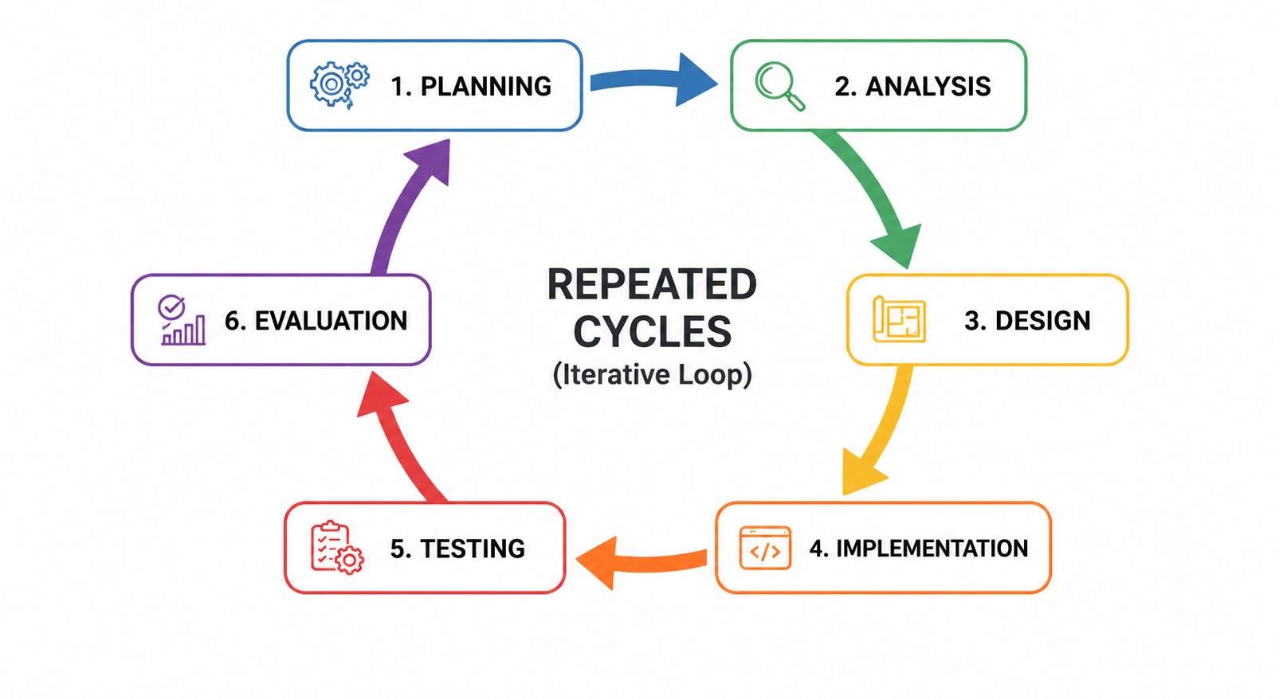
Every development cycle results in a certain functionality of the system starting from the possibility of uploading and cleaning data and gradually adding more features, including analysis, anomaly detection, and exportable findings as described by the cyclic framework in Figure 1.

Figure 1. Iterative Software Development Lifecycle

Iteration Planning
The first step of Smartalyze design was identifying typical problems associated with data preparation. While working with structured data, students, researchers, educators, small business owners, and other users do not necessarily have programming skills needed for efficient data cleaning and analysis. Data preparation can also be quite laborious since data may include missing values, duplicates, inconsistent formats, and other quality issues. Research papers devoted to data cleaning practices indicate that this is one of the most difficult stages of the analysis process [50].
To cope with these problems, the project made use of iterative approach to software development. This means that the system is developed in the form of manageable iterations instead of implementing all of its functions within one development period. Every iteration consists of planning, implementation, testing, and refinement phases enabling the development team to evaluate already implemented functionality and fix possible issues before going to the next iteration [51].
At the initial planning phase, the general goal of Smartalyze was identified, which was to design an AI-assisted, web-based system providing users with guidance on data cleaning, visualization, and basic analysis. The planned features were structured file upload, table extraction using OCR, dataset editing, rule-based common data quality issue detection, relationship-based recommendations, descriptive statistics, linear regression, IQR-based potential outlier detection, visualization, AI-assisted explanations, and data export.
Also at the planning stage, the scope of the project was defined. Smartalyze was expected to work with CSV, XLS, XLSX, and JSON datasets along with PNG and JPG images containing tables. The system was divided into separate functional units responsible for account management, files operations, OCR processing, dataset editing, cleaning, analysis, visualization, version control, and export. This will allow easier testing of the application and improvement of particular functionalities without having to redesign the whole architecture of the system.
Consideration of technical and resource requirements preceded the initiation of development activities. The technical requirements included the employment of Python processing environment, user-friendly browser-based interface, database, OCR software, statistical packages, visualization toolkits, and a locally installed language model for AI assistance during explanations. Among other things, the development team took into account the need for uploading limits, time for processing, hardware requirements, Internet accessibility, privacy issues, and user confirmation of recommendations.
A flexible development schedule was subsequently created. Basic functionalities were scheduled for iterations in such a way that authentication and file management were supposed to be developed before cleaning, analysis, visualization, AI assistance, and version management. Feedback and test results of one iteration were expected to be used as input data for the planning of the subsequent iteration. Such an approach enabled gradual polishing of Smartalyze's functionalities according to the project goals and functional requirements.
Project Team Organization
The organizational structure allows allocating certain responsibilities, which are crucial for successful development and implementation of Smartalyze. The team implements collaborative hierarchical structure that includes technical execution along with thorough analysis and documentation with the help of academic expertise.
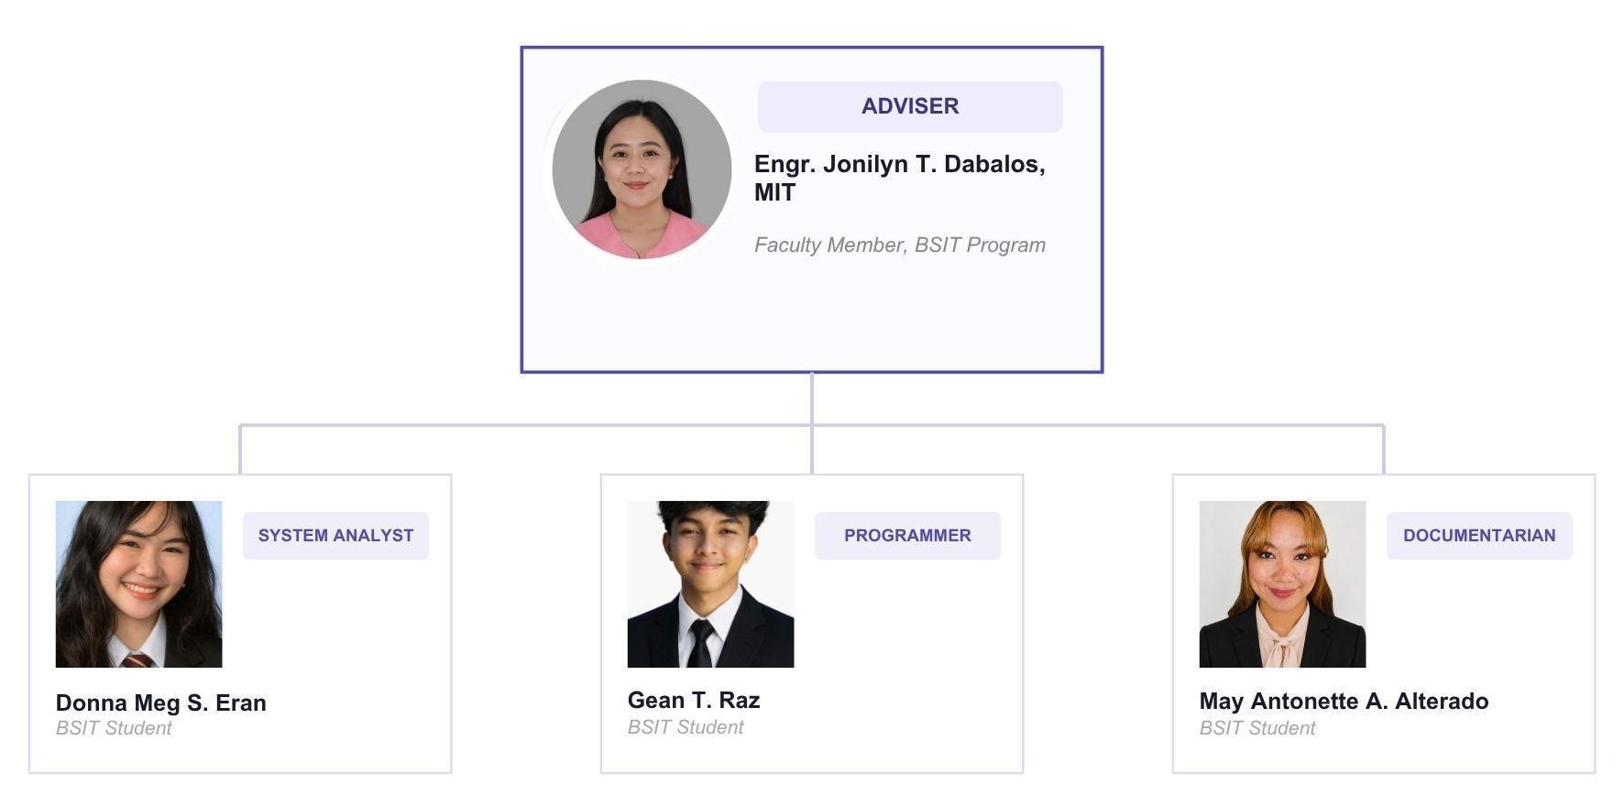
Project Adviser
The Project Adviser, Engr. Jonilyn T. Dabalos, MIT, is responsible for providing expert guidance and supervising the development process of the Capstone Project. She checks that the project corresponds to academic and technical requirements. The adviser examines the design of the system and methodologies and gives recommendations for improvement of the system's quality.
Systems Analyst
The Systems Analyst, Donna Meg S. Eran, is responsible for requirements and functionality analysis of the system and ensures that all its parts correspond to the project goals. The Systems Analyst analyzes user needs, determines system functionalities and maintains consistency of all modules of the system.
System Programmer
The System Programmer, Gean T. Raz, will develop and implement the system itself. It is his responsibility to make sure that the design of the system will be programmed properly, features of the system will be made, modules will be integrated, and finally, the system will be tested and debugged. The efficiency of the system should be achieved along with proper handling of different data formats.
Documentarian / Technical Writer
The Documentarian, May Antonette Alterado, will prepare all the necessary project documentation such as the system documentation, research manuscript, and technical reports. She will make sure that the documentation will be well-written and will contain the necessary information about the system as well as will comply with academic and technical standards.
Work Breakdown Structure (WBS)
The activities in Smartalyze project will be carried out following the Iterative Software Development Model. According to the model, the system will be developed in incremental iterations where every iteration will include the phases of planning, analysis, design, implementation, and testing.
Iteration 1 – Core System Setup: The iteration is devoted to basic project planning, gathering requirements on basic dataset formats (CSV, Excel, JSON), designing the client-server architecture, and implementing core web features (file uploading, database view).
Iteration 2 – Data Cleaning Module: This iteration is dedicated to examining commonly occurring data anomalies (such as missing values, duplication, and incorrect data type) and constructing the rule-based backend engine to detect such problems and provide automated solutions to the user.
Iteration 3 – Analysis and Intelligence Layer: Machine learning features will be integrated into the app to analyze deeper patterns in data, detect anomalies, and produce trend analysis of the uploaded datasets.
Iteration 4 – Visualization and Reporting: Visualization and Reporting: The focus here is on UX by developing minimalistic chart designs, graphic elements, data summaries, and reporting features that let users export the cleaned data.
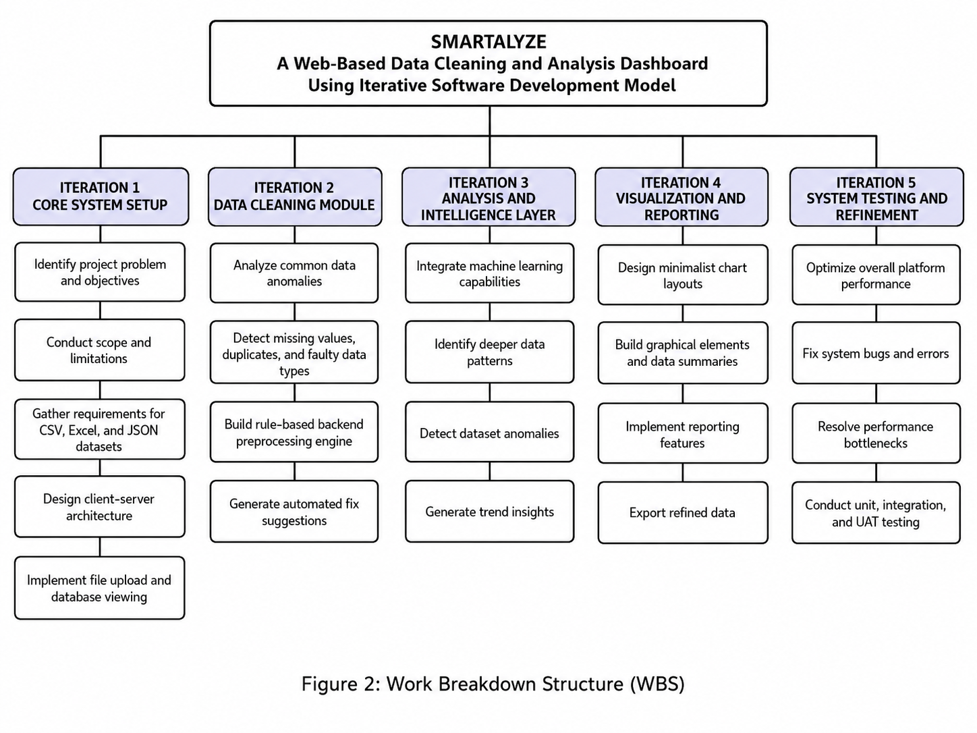
Iteration 5 – System Testing and Refinement: Testing and Optimization: The last effort will be devoted to system optimization, bug fixes, solving any performance problems, and general quality assurance through unit testing, integration testing, and user acceptance testing (UAT).

Figure 2. Work Breakdown Structure (WBS)
Gantt Chart

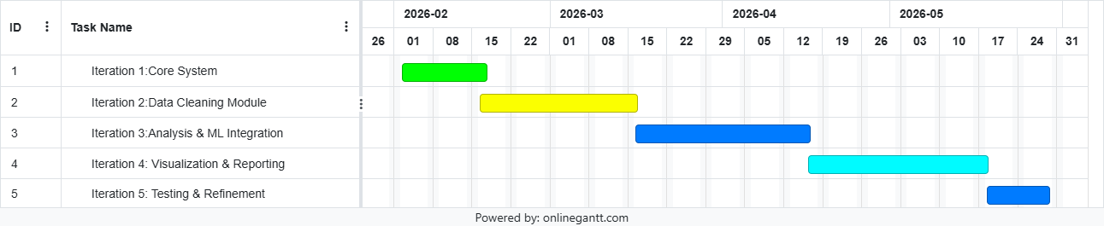
Project schedule and timeline for the execution of the WBS tasks are illustrated chronologically in Figure 3 below. In particular, the timeline above reflects the chronological steps involved in the execution of each iterative development phase from their respective weeks until the final completion date in May 2026. Through the visual representation illustrated in Figure 3 above, each system module is expected to flow to the other successively in order to ensure milestone accountability during the entire project life cycle.

Figure 3. Gantt Chart

System Analysis
In this chapter, the analysis of the Smartalyze system is carried out. Specifically, this chapter seeks to analyze how user needs are analyzed and integrated into the system functionality. In doing so, this chapter explains the conceptual framework, system requirements, and data processing within the system as users interact with the system. The objective is to develop a system that transforms raw structured datasets to meaningful insights for non-technical people.
As per the Iterative Software Development Model, system analysis is continually reviewed and improved across various cycles for data processing and analysis as well as user interaction.
Conceptual Framework
The conceptual framework of Smartalyze will involve the use of the Input-Process-Output Model to explain how uploaded datasets will flow through the system to produce structured output data.
Input stage will feature structured datasets submitted by users in CSV, XLS, XLSX, and JSON formats. Also, the input stage will incorporate PNG and JPG images containing tabular information. In relation to image-based input, the Optical Character Recognition will extract the visible text in the image and convert it to a structured dataset which is viewable and further processed in the platform.
In the process stage, Smartalyze will validate and control the uploaded files prior to performing the data preparation and analysis. The users will be allowed to edit the datasets, add/remove columns, change headers and save the works in drafts for further editing. Further, the system will detect some common data quality problems, such as missing values, duplicate rows, inconsistent data types, unnecessary spaces, inconsistent casing, and invalid dates. Furthermore, relationship-based suggestions will be performed in cases where there are relevant fields which can be applied in suggesting missing values.
Upon the dataset preparation, some of the operations will involve performing basic analytical operations such as descriptive statistics, grouping, summarizing, trends analysis through linear regression and anomaly detection through Interquartile Range approach. Moreover, it will generate relevant visualization and AI-based explanations for the user.
The output of the process will include cleaned and edited datasets, descriptive statistics results, summarized and grouped data, interactive visuals, trend analysis results, anomaly detection results, relation-based recommendations, and AI Insights. It will also be possible to export supported datasets and selected analysis results in supported formats.
Using the IPO Model, the model will show how Smartalyze will turn raw and incomplete data into information. The generated AI insights will work as an explanation and recommendation that might help users interpret their data, but they cannot replace any professional statistical analysis, expert judgment, and user decision.

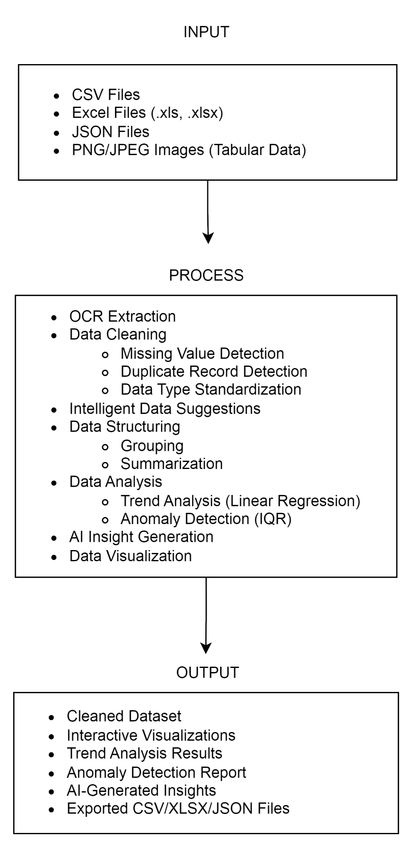

Figure 4. Conceptual Framework

System Architecture
Smartalyze uses a web-based client-server architecture that allows accessing the system through the regular browser with no need in local installation. This architecture gives possibilities for scalability and accessibility of the system and centralizes data processing.
This system consists of the following components:

Hardware Components
This system works in a centralized server environment where data processing, storing, and computing take place. End-users use client devices like desktop computers or laptops with internet access to enter the system and work there. This architecture allows managing centralized datasets, analysis processes, and other system resources while giving the possibility to access the system through the browser.

Software Components
The frontend is implemented using a browser-based user interface that provides an interactive environment for users to upload data sets, view output and carry out functions without prior coding knowledge.
The backend makes use of Python-based data processing libraries to conduct data cleaning processes based on certain rules as well as carry out machine learning algorithms to detect trends and anomalies.

Data Components
The data set used in the project involves structured data supplied by the user in formats such as CSV, Excel, and JSON. Such data sets are subject to validation, preprocessing, analysis, and transformations.
Processing Components
The Data Processing Engine acts as the core analytical component of the system. This component undertakes tasks including OCR extraction, data cleaning, machine learning-based trend analysis, anomaly detection, and visualization preparation before presenting outputs to the user.

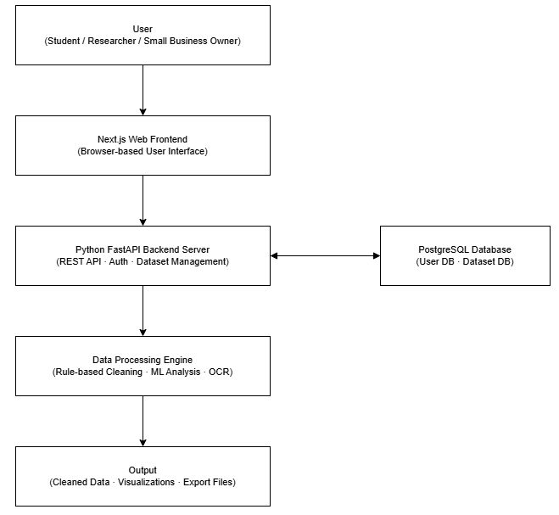

Figure 5. Smartalyze System Architecture

As depicted in Figure 5, Smartalyze adopts a web-based client-server design architecture. Interactions are made possible using the browser-based frontend while requests are processed by the FastAPI backend. The backend connects to both the PostgreSQL database and the Data Processing Engine, which takes care of OCR extraction, data cleaning, trend analysis, anomaly detection, visualization preparation and presentation of outputs to the user.

Functional and Non-Functional Requirements

Functional Requirements
The Smartalyze system shall have the following functional requirements according to its intended use for automated data preparation, visualization, and simple analysis purposes:

1. User Authentication and Account Management. Users can create, sign-in, sign-out, and manage his/her own account. The user has access and can manage his/her datasets only.

2. Dataset Upload and File Management. Users can upload CSV, XLS, XLSX, JSON, PNG, or JPG files that are checked for correctness and size prior to processing. Users can organize and delete his/her uploaded datasets.

3. OCR Processing. Smartalyze processes tabular data extracted from uploaded PNG or JPG images using OCR and creates a structured editable dataset from this information.

4. Dataset Editing. Users can modify cell content, add or remove columns, change column names. Saving draft of a not finished dataset is planned as an additional feature for the next version.

5. Data Cleaning. Smartalyze detects missing values, duplicates, inconsistency in data type, casing, white-space, date validation and suggests cleaning for user confirmation.

6. Relationship-Based Data Recommendations. Smartalyze detects relationships between different columns and recommends missing values that the user can confirm before making any changes.

7. Data Analysis. Smartalyze performs descriptive analysis, grouping/summarizing, linear regression trend analysis and IQR-based anomaly detection and gives an AI-assisted explanation of these results.
8. LLM Comparison and AI-Assisted Explanation Generation. Three selected LLMs will be compared for accuracy, clarity, consistency, response time, connectivity, resource usage, and integrability. Groq will be selected to provide an understandable AI-assisted explanation of cleaning and analytical results.

9. Data Visualization. The system is capable of generating bar charts, line graphs, pie charts, area charts, histograms, and frequency distribution based on compatible column types.

10. Progress Monitoring. The system displays a progress indicator during file uploads, OCR, cleaning, analysis, visualization, and export.

11. Data Export. Users are able to export cleaned datasets and analytical outputs chosen by the user in the supported system formats.

12. Dataset Version Management. The system saves previous versions of datasets and allows users to restore their previous version anytime.

Non-Functional Requirements
The Smartalyze system shall meet the following non-functional requirements in order to guarantee its quality, reliability, security and performance

1. Performance Efficiency. The system shall process files up to 20 MB in size and display progress indicators during major processes. Three LLMs will be evaluated according to their response time and resource usage, and Groq will be chosen due to its efficient cloud-based processing and lower usage of resources on the user's computer.

2. Reliability. The system shall maintain data integrity during all the operations performed by the user with datasets and shall always be available to authorized users if the server is running (Availability). Saved datasets and their versions shall stay in the system until modified or deleted by the user.

3. Security. The system shall ask the user for his/her credentials to use all dataset and analytical functions, and encrypt passwords. Each user's data shall be isolated and shall not be available to anyone but its owner.

4. Interaction Capability. The system shall have an easy to use interface that would not require a high level of technological skills from the user.

5. Maintainability. The system shall have a modular architecture so that file formats, cleaning approaches, visualization techniques and analytical capabilities can be added or changed without affecting other parts of the system.

6. Flexibility. The system shall allow multiple users and datasets to be processed simultaneously while retaining good performance (Scalability).

7. Compatibility. The system should be compatible with modern web browsers (Chrome, Edge, Firefox, Safari), and no extra software installation should be needed to use the system.

8. Functional Suitability. Outputs generated by the system (OCR extraction, statistics, trend analysis, anomalies, recommendations, and AI explanations) should accurately represent the quality and completeness of the uploaded data and require further review by the user prior to implementation.
9. LLM Connectivity, Availability, and Security. The system shall employ Groq to generate cloud-based AI explanations. Internet access will be required, as well as API credential security, transferring only necessary data, and displaying a notification when there is a problem with the service without affecting the saved datasets or the result. All generated explanations should require further review by the user.
Use Case Diagram
The functional interactions between the user and the various platform components are presented in Figure 6 below.
- Primary Actor: Non-technical User (Student, Researcher, Small Business Owner).
- As illustrated within the system boundary in Figure 6, the primary actor triggers the main actions such as Register, Login, Upload Dataset, View Dataset, List Datasets, Apply Cleaning Operations, Detect Data Quality Issues, Save Result, Export Dataset/Result, and Delete Dataset. Functional entry points enable the user to navigate the data preparation process without writing any code.

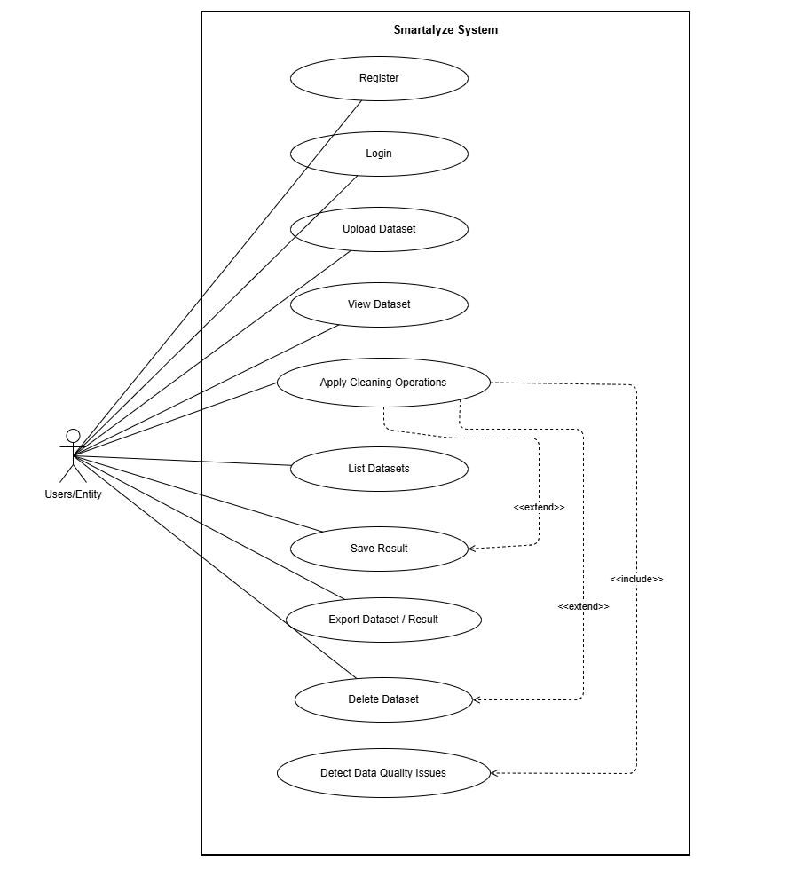
Figure 6. Use Case Diagram

Context Flow Diagram

In accordance with Gane and Sarson notation, the Level 0 DFD depicted in Figure 7 describes the logical flow of business actions between the user and the whole Smartalyze system as one process.

External Entities: User, LLM Provider
Process 0: Smartalyze: An AI-Assisted Data Visualization and Analysis Platform
Input (User -> System): Login Credentials / Registration; Dataset Files (CSV, Excel, JSON, PNG/JPG); Cleaning / Apply Requests; Analysis Requests / AI Questions / Export Requests
Output (System -> User): Authentication Token / Status; Dataset Preview / Health Summary; Cleaning Results / Analysis Results / Charts; AI Suggestions / Chat Reply / Exported File
Input (LLM Provider -> system): Cleaning Plans / Chat Responses
Output (System -> LLM Provider): Dataset Context (schema + issue summary)

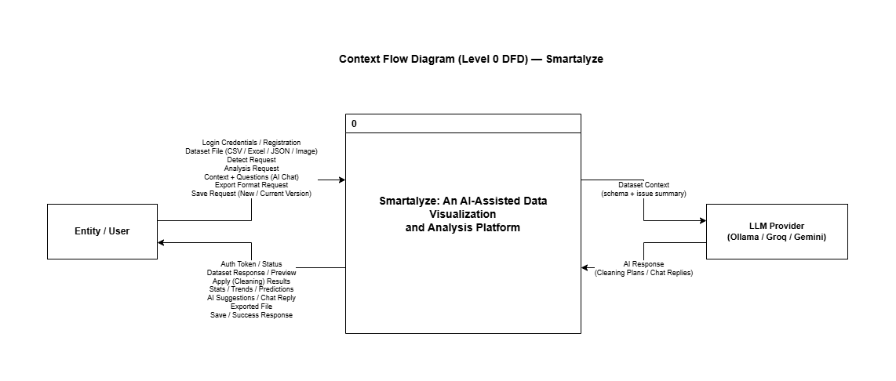
Figure 7. Level 0 (Context Flow Diagram)

Level 1 Data Flow Diagram
The Level 1 DFD provides a more detailed decomposition of the Smartalyze system. It breaks down the only process of the Level 0 diagram into several sub-processes which interact. This diagram is created using the Gane and Sarson approach and shows how data flows through the system from input by the user to the output by the system and how it interacts with data stores of the system.
The diagram shows how the user interacts with Smartalyze sub-processes and with the main data stores: the User Database (accounts and sessions) and the Dataset Database (datasets, snapshots, and actions). The external component of LLM Provider (Ollama / Groq / Gemini) is used to provide the AI Advisory process. Smartalyze stores the dataset contents as snapshots in JSON format and returns results of cleaning, analysis, and export files according to the current or specified snapshot.
Processes:
1.0 User Authentication Module: User registration, login authentication, and session management through credentials checking and authentication tokens.
2.0 Dataset Management Module: Deals with the upload, structure validation, preview, listing, and deletion of the structured dataset in various forms such as CSV, Excel, JSON and image based (PNG/JPG) datasets that go through the OCR pipeline.
3.0 Data Cleaning (Detect and Apply): Carries out rule-based anomaly detection involving missing values, duplicates, and inconsistency in data types in the dataset snapshot, and on-the-fly cleaning without immediate overwriting of the permanent dataset in the database.
4.0 Export Dataset/Result: Creates and serves to the user as a downloadable file (CSV, XLSX, or JSON file) from either a permanently stored dataset snapshot or an uncommitted cleaning workspace snapshot.
5.0 Save Result: Persists the clean data snapshot either by versioning and overwriting the current file or saving the result as a completely new dataset.
6.0 Analysis and Prediction: Processes user analysis/prediction request by fetching current snapshot of the dataset from the Dataset Database and provides statistical summaries, trend direction, and anomalies and predictions using Linear Regression for numerical columns.
7.0 AI Advisory: Takes in user context and questions, generates a concise dataset summary from the current snapshot and the metadata available in the Dataset Database, sends it out to the external LLM Provider, and gets back AI-generated advice or responses to help the user clean up and interpret the data.
Data Stores (Referenced in the Level 1 DFD):
D1 User Database: Hosts user account information, password hashes, session status, and token validation information.
D2 Dataset Database: Holds the key database architecture through storing metadata about the datasets, versions of file content in snapshots, and detailed audit logs and action logs.

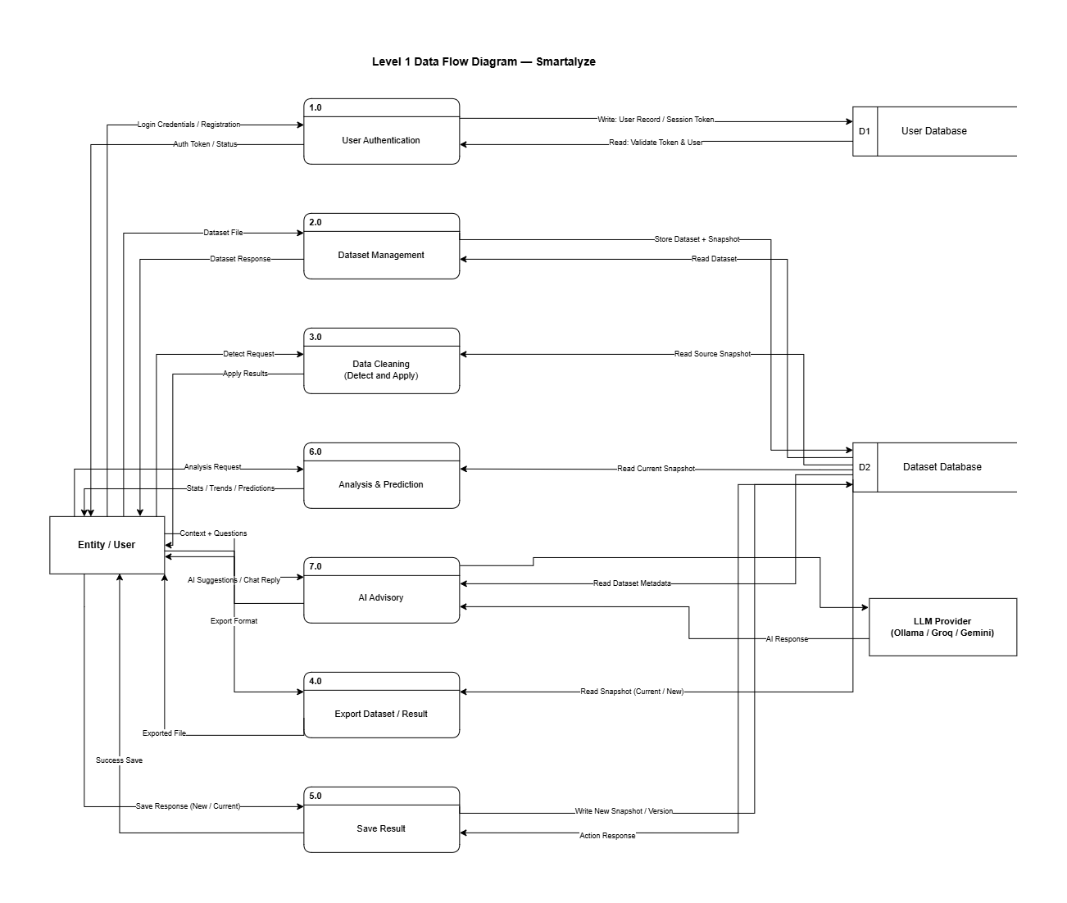
Figure 8. Level 1 (Data Flow Diagram)
System Design

In this section, the design artifacts for the database architecture of Smartalyze are presented. The following pieces make sure that the data model accommodates all the functional requirements.

Entity Relationship Diagram (ERD)

Entity-Relationship Diagram: This diagram displays the logical structure of the database in terms of entities and their relationship within the Smartalyze application.
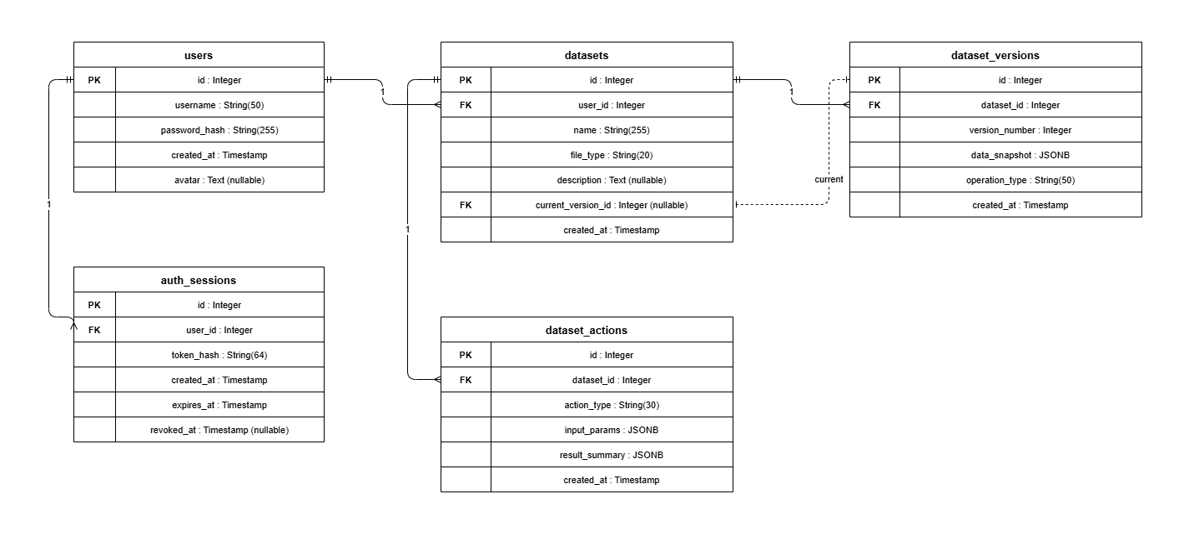Figure 9. ERD (Entity-Relationship Diagram)

Data Dictionary
Data Dictionary is a well-organized reference guide that gives detailed information about all the data entities used in the Smartalyze application. The data entities in the database have their attributes, data types, keys, and descriptions defined. The following model helps to maintain uniformity in data processing and facilitates system development and maintenance.
Table 3. Users
Attribute | Data Type | Key Type | Description
user_id | Integer | Primary Key | Unique identifier for each user
username | Varchar | — | Username used for login
password_hash | Varchar | Unique | Hashed password for auth
created_at | Timestamp | — | Date and time the user account was created

Table 4. AuthSessions
Attribute | Data Type | Key Type | Description
user_id | Integer | Foreign Key | References the user who owns the session
token_hash | Varchar | unique | Hashed authentication token (Bearer token stored securely)
created_at | Timestamp | — | Date and time the session is created
expires_at | Timestamp | — | Date and time the session expires
revoked_at | Timestamp | — | Date and time the session was revoked (null if active)

Table 5. Datasets
Attribute | Data Type | Key Type | Description
id | Integer | Primary Key | Unique identifier for each dataset
user_id | Integer | Foreign Key | References the user who owns the dataset
name | varchar | — | Dataset name
file_type | varchar | — | Dataset format
description | text | — | Optional user dataset desc
current_version_id | integer | Foreign Key | Reference to the current dataset snapshot
created_at | Timestamp | — | Date and time the dataset was created/uploaded

Table 6. Dataset Versions
Attribute | Data Type | Key Type | Description
id | Integer | Primary Key | Unique identifier for each dataset snapshot/version
dataset_id | Integer | Foreign Key | References the dataset this snapshot belongs to
version_number | integer | — | Version sequence number within a dataset like 1 2 3
operation_type | varchar | — | Label for how the snapshot was created (e.g., upload, cleaning, result)
data_snapshot | JSONB | — | Full stored snapshot of the dataset content, including records/preview/summary
created_at | Timestamp | — | Date and time the snapshot was created

Table 7. Dataset_Actions
Attribute | Data Type | Key Type | Description
id | Integer | Primary Key | Unique identifier for each dataset action event
dataset_id | Integer | Foreign Key | References the dataset affected by the action (datasets.id)
action_type | varchar | — | Type of action performed (e.g., upload, result, delete)
input_params | JSONB | — | Input parameters used for the action (stored as JSON)
result_summary | JSONB | — | Summary of outputs/results for the action (stored as JSON)
created_at | Timestamp | — | Date and time the action was recorded

Technologies, Concepts, and Theories

The following section explains the basic concepts, algorithms, and latest technologies that form the basis of Smartalyze application. It involves complete flow from data collection to data analysis and describes the technologies used in developing the Smartalyze application.

Data Collection
Data collection in Smartalyze is done by users themselves. There are no external APIs or third parties which collect any data in the Smartalyze application. Users simply upload their own structured data via web interface.

Supported File Types
- CSV (Comma-Separated Values)
- Excel (.xlsx, .xls)
- JSON (JavaScript Object Notation)
- Image file with tabular data (PNG, JPG)

Dataset Validation
During the process of uploading, Smartalyze runs structural validation to verify that:
- The file is readable.
- The file is well-formatted.
- Rows and columns are tabular in structure.
- All required schema attributes exist.

Data Extraction Using OCR
In case of image files, Smartalyze runs an OCR pipeline before validation.
OCR helps to convert text present in images into readable machine data. Tools used in this step are:
- EasyOCR – It extracts text from images.
- img2table – It detects tables and table cells from images.
Using these tools:
- Table regions in images are detected.
- Cells are extracted.
- Column names are identified.
- The table is reconstructed into DataFrame.
This feature allows users to convert any printed or scanned document into digitized format.

Dataset Storage
After validation:
- Content of the dataset is converted into a JSONB snapshot.
- Snapshot is saved on PostgreSQL database.
- The uploaded dataset becomes Version 1 of the dataset.
This is snapshot-based method, which ensures that the original dataset is maintained no matter how many times it is cleaned or transformed.

Data Pre-processing
The preprocessing step is the most important part of the Smartalyze pipeline since uploaded datasets may have some problems in terms of data quality which affect analytical accuracy.
Smartalyze applies a rule-based preprocessing engine which is developed using Python with the pandas library.

Missing Value Detection and Handling
The system identifies:
- Null values
- Empty cells
- Pseudo-null values such as:
  - "N/A"
  - "none"
  - "-"
  - "unknown"

Information Provided to Users
- Missing value count per column
- Missing value percentage
- Severity indicators

Resolution Strategies
Users may choose to:
- Fill with column mean (numeric data)
- Fill with column median (skewed numeric data)
- Fill with column mode (categorical data)
- Remove affected rows
Smartalyze keeps the current precision of the decimal numbers while working with numeric imputations.

Duplicate Record Detection and Removal
The system recognizes cases when values of all columns are equal.

Benefits
- Prevents inflated counts
- Reduces analytical bias
- Improves dataset reliability
Detected duplicates can be removed with one click.

Data Type Standardization
Smartalyze determines data types of columns and compares them with stored data types.

Supported Data Types
- Numeric
- Datetime
- Categorical
- Boolean
- Text

Examples
If a column has values like:
₱1,500
₱2,000
₱3,250
then it will be stored as text data type, but detected as numeric.

Supported Conversions
- Currency symbols
- Thousands separators
- Date format variations
- Boolean representations:
  - Yes/No
  - True/False
  - 1/0

Additional Preprocessing Operations
Smartalyze also supports:
- Whitespace trimming
- Lowercase conversion
- Date standardization
- Category value mapping
- Derived column creation
- Outlier nullification using IQR
- Pattern-based value imputation

Execution Order
Operations are performed in a deterministic way:
- Type conversions
- Missing value filling
- Row removals
- Sorting operations
It avoids order-dependence problems in operations.

Feature Extraction
Feature extraction converts preprocessed data into features and statistical characteristics which can be used in analysis.

Column Type Identification
After preprocessing, each column is classified as:
- Numeric
- Datetime
- Boolean
- Categorical
- Text
- Unknown
Classification defines possible analyses and visualizations for each column.

Statistical Feature Computation
For each numeric column, Smartalyze calculates:
- Count
- Missing value count
- Missing value percentage
- Unique value count
- Mean
- Median
- Standard deviation
- Minimum value
- Maximum value
- First Quartile (Q1)
- Third Quartile (Q3)
These statistics are available in the Column Analysis view.

Aggregation and Grouping
Users can create groups of data by categorical attributes and apply aggregations to numeric data.

Supported Aggregations
- Sum
- Count
- Mean
- Minimum
- Maximum

Example Applications
- Total sales per region
- Average grades per department
- Monthly transaction summaries

Distribution Analysis

Numeric Columns
Smartalyze creates equal-width histograms which are used to visualize distribution of the values.

Categorical Columns
- Counts top 20 most frequent categories.
- Produces Frequency Distributions.

Datetime Columns
Data is grouped by:
- Year
- Year-Month
based on the length of the period of the dataset used.

Classification and Analysis
Smartalyze employs machine learning and statistics techniques to detect patterns, trends, and anomalies.

Trend Analysis (Linear Regression)
Smartalyze uses the Linear Regression model from Scikit-learn library.

Model Inputs
- Independent Variable:
  - Row index
  - Time dimension (if available)
- Dependent Variable:
  - Numeric column values

Interpretation
Condition | Interpretation
Positive slope | Increasing trend
Negative slope | Decreasing trend
Near-zero slope | Stable trend
R² < 0.1 | Volatile pattern

R-Squared (R²)
R squared determines how well the regression line can explain the variability in the data.

Anomaly Detection (IQR Method)
For each numeric column, Smartalyze computes:
IQR=Q3−Q1IQR = Q_3 - Q_1IQR=Q3​−Q1​
Values are classified as anomalies when they fall outside:
- Lower Bound:
  - Q1 − 1.5 × IQR
- Upper Bound:
  - Q3 + 1.5 × IQR

Advantages
- Resistant to skewed distributions
- Does not require normally distributed data
- Suitable for domain-independent datasets

Prediction (Linear Regression Forecasting)
Building on trend analysis, Smartalyze can forecast future values.

Features
- User-defined forecast horizon
- 1–20 future prediction steps
- Confidence bands based on regression residual error

Outputs
- Predicted future values
- Trend visualization
- Confidence intervals
Technologies Used in Development
The development of Smartalyze utilizes modern web, database, machine learning, and OCR technologies to support automated data cleaning, analysis, visualization, and export functionalities. These technologies were selected based on their compatibility, scalability, and suitability for developing a user-friendly platform for non-technical users.

Frontend Technologies

Next.js 16 (App Router)
Purpose: Frontend Framework
Used For:
- Application routing
- Page rendering
- Dashboard interface
- Dataset workspace
- Authentication pages

React 19
Purpose: User Interface Library
Used For:
- Data tables
- Cleaning operation queues
- Charts and visualizations
- AI advisory components

TypeScript 5
Purpose: Statically Typed JavaScript
Benefits:
- Type safety
- Improved maintainability
- Better developer experience

Tailwind CSS 4
Purpose: Utility-First CSS Framework
Used For:
- Layout design
- Typography
- Responsive interfaces
- Consistent styling

Recharts 3
Purpose: Data Visualization Library
Used For:
- Bar charts
- Line charts
- Pie charts
- Area charts

Backend Technologies

Python 3.12
Purpose: Core Backend Language
Used For:
- Data processing
- Machine learning
- API development
- Dataset management

FastAPI 0.135
Purpose: Backend API Framework
Used For:
- Authentication endpoints
- Dataset operations
- Cleaning services
- Analysis services
- Export functionality

pandas 3
Purpose: Data Processing Library
Used For:
- Data cleaning
- Type inference
- Missing value handling
- Statistical computation
- Dataset transformations

scikit-learn 1.8
Purpose: Machine Learning Library
Used For:
- Linear regression
- Trend analysis
- Forecasting

Database Technologies

PostgreSQL
Purpose: Primary Database Management System
Features Used:
- JSONB storage
- Dataset snapshots
- Structured and semi-structured data storage

SQLAlchemy 2 (Async)
Purpose: ORM and Database Toolkit
Benefits:
- Asynchronous database operations
- Non-blocking API performance
- Simplified database interaction

OCR Technologies

EasyOCR
Purpose: Text Extraction
Capabilities:
- Multi-language OCR
- Printed text recognition
- Table cell text extraction

img2table
Purpose: Table Detection
Capabilities:
- Detects table boundaries
- Identifies rows and columns
- Reconstructs tabular layouts
Together, EasyOCR and img2table form Smartalyze's OCR pipeline.

Artificial Intelligence Technologies

Ollama
Purpose: Local LLM Inference
Benefits:
- Offline deployment
- Enhanced privacy
- Open-source model support

Groq
Purpose: Cloud-Based LLM Inference
Benefits:
- High-speed responses
- Cloud-hosted processing

Gemini
Purpose: Cloud-Based Large Language Model
Benefits:
- Advanced natural language understanding
- AI advisory functionality

Privacy Protection
Only summarized dataset metadata is transmitted to the LLM, including:
- Column names
- Column types
- Dataset statistics
- Issue counts
Raw dataset rows are never transmitted, helping protect user privacy and sensitive information.

System Testing and Implementation
In this section, the test procedures and implementation plan will be described for assessment of functionality, performance, reliability, and usability of the proposed Smartalyze system. Testing of the system will be undertaken to check whether the Smartalyze system fulfills the set functional and non-functional requirements. In other words, testing will be carried out on accuracy of the data cleaning operation, machine learning assisted analysis, visualization generation, and export of the dataset.

System Test Plan
The tests of the Smartalyze system will involve several types of tests aimed at assessing the proper functionality of the system's components. These tests include unit testing, integration testing, usability testing, and user acceptance testing (UAT).
Test Area | Test Objective | Expected Result
User Authentication | Verify user registration and login functionality. | Users will successfully access their accounts using valid credentials .
Dataset Upload | Verify uploading of CSV, Excel, and JSON files | Uploaded datasets will be accepted and displayed correctly
OCR Extraction | Verify extraction of text from image-based documents | Text will be extracted and converted into a usable dataset format
Missing Value Detection | Verify identification of incomplete records | Missing values will be detected and highlighted
Duplicate Detection | Verify identification of repeated records | Duplicate entries will be detected and reported
Data Type Validation | Verify consistency of data formats | Incorrect data types will be identified and flagged
Data Cleaning Operations | Verify cleaning functions | Selected cleaning operations will be successfully applied
Trend Analysis | Verify generation of trends and summaries | Relevant patterns and summaries will be generated
Anomaly Detection | Verify identification of unusual data points | Anomalies and outliers will be detected and reported
Data Visualization | Verify chart and dashboard generation | Visual representations will be displayed correctly
Data Export | Verify exporting of processed datasets | Cleaned datasets will be downloaded in the selected format

Table 8. System Test Plan

Testing Approach

Unit Testing
Firstly, unit testing will be conducted on each module of the Smartalyze system separately, to see that each of them performs its tasks properly. Such unit testing will be carried out on such functionalities as file upload, OCR data extraction, missing values handling, duplicates identification, data type validation, trend analysis, outliers identification, visualization generation, and export of the results of analysis.

Integration Testing
Integration testing will be performed to make sure that all modules of the Smartalyze system are working together properly. This test will assess the whole workflow of the system from the stage of dataset uploading till generation of visualizations and export of dataset.

Usability Testing
Usability testing will be performed by selected students, researchers, and small business owners. The goal of this testing will be to find the possible gaps in the user friendliness and usability of the system.

User Acceptance Testing (UAT)
The UAT will test how far the requirements set by potential users have been met by the Smartalyze system.

Summary of Findings
After the completion of testing, a summary and presentation of the test findings will be done using a tabular form.
Test Area | Number of Test Cases | Passed | Failed | Success Rate
User Authentication | TBD | TBD | TBD | TBD
Dataset Upload | TBD | TBD | TBD | TBD
OCR Extraction | TBD | TBD | TBD | TBD
Missing Value Detection | TBD | TBD | TBD | TBD
Duplicate Detection | TBD | TBD | TBD | TBD
Data Type Validation | TBD | TBD | TBD | TBD
Data Cleaning Operations | TBD | TBD | TBD | TBD
Trend Analysis | TBD | TBD | TBD | TBD
Anomaly Detection | TBD | TBD | TBD | TBD
Data Visualization | TBD | TBD | TBD | TBD
Data Export | TBD | TBD | TBD | TBD
Table 9. Summary of Testing Results
Note: Test findings will actually be presented in the implementation and evaluation stage of the project.

System Implementation Plan
The implementation plan will make sure that Smartalyze gets thoroughly tested, improved and prepared for deployment.
Phase | Activity | Description
Phase 1 | System Preparation | Prepare the development environment, database, backend services, and frontend interface
Phase 2 | Module Integration | Integrate the upload, OCR, cleaning, analysis, visualization, and export modules
Phase 3 | Internal Testing | Conduct unit and integration testing to identify and correct errors
Phase 4 | Pilot Testing | Allow selected users to evaluate the system and provide feedback
Phase 5 | User Feedback Collection | Gather comments and recommendations from pilot users
Phase 6 | System Refinement | Apply improvements based on testing results and user feedback
Phase 7 | Final Deployment | Deploy the completed system for presentation and evaluation
Table 10. System Implementation Plan
Testing outcomes will serve as a foundation for further development and optimization of the system.

System Maintenance
This section presents maintenance activities to be done to guarantee the ongoing reliability, security, usability and performance of the Smartalyze application after deployment. Because at the moment the project has not passed the implementation and maintenance stages, all activities are listed using future tense.

Smartalyze System Security Plan
Smartalyze system will use security methods to keep user accounts, uploaded datasets and processing results safe from any potential threats.

Authentication of Users and Access Control

The system will require registration and login of users who want to access any system features. Authentication will be used to allow access to uploading, processing, analyzing and exporting of datasets exclusively to registered users.

User Password Protection
Passwords will not be saved in plaintext format in the database. They will be encrypted using the hashing algorithm prior to saving in the database. It will minimize risks of any threat connected to this sensitive information.

File Upload Security
These will have validation to ensure that the system accepts only allowed formats such as CSV, Excel, JSON, PNG and JPG files. Any other invalid or possibly harmful files will not be accepted to mitigate any potential security threats.

Data Protection
All uploaded and computed files from the system will be protected and stored safely within the database. The stored information will be accessible to the authentic users and the authorized system administrators.

Backup and Recovery Plan
Proper backup procedures will be done to reduce or completely eradicate possible data loss due to any unexpected failure of the hardware, software errors or other interruptions in the process.

Maintenance plan for the system
The Smartalyze system will experience various forms of maintenance procedures to maintain its functionality, efficiency and usability.

Corrective Maintenance
This is carried out any time when software problems occur or bugs in the system are found out. Any issue found out by the users while using the system will be fixed.

Adaptive Maintenance
This kind of maintenance will be carried out whenever there are any alterations in the software environment, web technology, browsers, or OS needs.

Perfective Maintenance
Perfective maintenance aims at making the system more efficient by optimizing performance, processing speed, UI and the user experience. This will involve considering both user's evaluations as well as their reviews.

Preventive Maintenance
This type of maintenance will always be done regularly to make sure that there will be no problems in future.

Model and Rule Updates
The rule-based preprocessor and machine-learning components will be evaluated and revised from time to time to enhance anomaly detection, trend detection, and data quality assessment abilities. Enhancements in the future could include other analytic procedures according to requirements.

System Monitoring
The developers will continuously assess various indicators of the system’s performance such as processing time, storage space usage, and overall system responsiveness. System monitoring will assist in identifying possible system bottlenecks.

REFERENCES
[1] S. Samarasinghe and S. Lokuge, “Exploring the Critical Success Factors for Data Democratization,” arXiv preprint arXiv:2212.03059, 2022, doi: 10.48550/arXiv.2212.03059.
[2] T. Petricek, G. J. J. van den Burg, A. Nazábal, T. Ceritli, E. Jiménez-Ruiz, and C. K. I. Williams, “AI Assistants: A Framework for Semi-Automated Data Wrangling,” arXiv preprint arXiv:2211.00192, 2022.
[3] M. Guo et al., "Normal Workflow and Key Strategies for Data Cleaning Toward Real-World Data: Viewpoint," Interact. J. Med. Res., vol. 12, p. e44310, 2023. [Online]. Available: https://doi.org/10.2196/44310 Cited by: 76
[4] R. Nasfi, G. de Tré, and A. Bronselaer, "Improving Data Cleaning by Learning From Unstructured Textual Data," IEEE Access, vol. 13, pp. 36470–36491, 2025. [Online]. Available: https://doi.org/10.1109/access.2025.3543953 Cited by: 12
[5] S. Strasser and M. Klettke, "Transparent Data Preprocessing for Machine Learning," in Proc. Workshop Human-In-the-Loop Data Anal. (HILDA), 2024, pp. 1–6, doi: 10.1145/3665939.3665960.
[6] M. Bilal et al., "Auto-Prep: Efficient and Automated Data Preprocessing Pipeline," IEEE Access, vol. 10, pp. 107764–107784, 2022, doi: 10.1109/access.2022.3198662.
[7] J. L. M. Pereira, M. J. Fonseca, A. Lopes, and H. Galhardas, “Cleenex: Support for User Involvement During an Iterative Data Cleaning Process,” ACM Journal of Data and Information Quality, vol. 16, no. 1, Art. no. 6, 2024, doi: 10.1145/3648476.
[8] Y. Ou, Y. Luo, J. Zheng, L. Wei, S. Qiao, J. Zhang, D. Zheng, H. Chen, and N. Zhang, “AutoMind: Adaptive Knowledgeable Agent for Automated Data Science,” arXiv preprint arXiv:2506.10974, 2025, doi: 10.48550/arXiv.2506.10974.
[9] Department for Digital, Culture, Media & Sport, “UK National Data Strategy,” UK Government, Sep. 9, 2020, updated Dec. 9, 2020. [Online]. Available:https://www.gov.uk/government/publications/uk-national-data-strategy
[10] Smart Nation and Digital Government Office, Singapore National AI Strategy 2.0, Government of Singapore, 2023. [Online]. Available: https://www.smartnation.gov.sg/publications/frameworks-and-blueprints/
[11] National Economic and Development Authority, Philippine Development Plan 2023–2028, Government of the Philippines, 2023. [Online]. Available: https://pdp.depdev.gov.ph/philippine-development-plan-2023-2028/
[12] Department of Science and Technology, Harmonized National Research and Development Agenda 2022–2028, Government of the Philippines, 2022. [Online]. Available: https://www.dost.gov.ph/knowledge-resources/downloads/file/5669-harmonized-national-r-d-agenda-2022-2028.html
[13] Republic Act No. 12254, “E-Governance Act,” Sept. 5, 2025. [Online]. Available: https://www.lawphil.net/statutes/repacts/ra2025/ra_12254_2025.html
[14] Davao del Norte State College, Book of Abstracts. [Online]. Available: https://dnsc.edu.ph/book-of-abstract/
[15] Davao del Norte State College, “DNSC Facilitates 2026 In-House Review of Research and Extension Projects,” Apr. 13, 2026. [Online]. Available: https://dnsc.edu.ph/dnsc-facilitates-2026-in-house-review-of-research-extension-projects/
[16] United Nations, “Goal 4: Ensure inclusive and equitable quality education and promote lifelong learning opportunities for all,” Sustainable Development Goals. [Online]. Available: https://sdgs.un.org/goals/goal4
[17] United Nations, “Goal 9: Build resilient infrastructure, promote inclusive and sustainable industrialization and foster innovation,” Sustainable Development Goals. [Online]. Available: https://sdgs.un.org/goals/goal9
[18] Davao del Norte State College, “DNSC Hosts CHED Commissioner Apag, Board Members for 125th BOT Meeting,” Mar. 24, 2026. [Online]. Available: https://dnsc.edu.ph/dnsc-hosts-ched-commissioner-apag-board-members-for-125th-bot-meeting/
[19] H. Wu, “A Brief Introduction to Data Preprocessing,” in Proc. 2nd Int. Conf. Eng. Manage., Inf. Technol. Intell. (EMITI 2025), 2025, pp. 216–221, doi: 10.5220/0014325400004718.
[20] Y. Tian, W. Shao, and Z. Deng, “Marketing-AutoM3L: Domain-aware automated machine learning for financial customer analytics,” Frontiers in Artificial Intelligence, vol. 9, Art. no. 1726900, Jan. 2026, doi: 10.3389/frai.2026.1726900.
[21] K. Wulff and H. Finnestrand, “Data-driven information for action,” Gruppe. Interaktion. Organisation. Zeitschrift für Angewandte Organisationspsychologie, vol. 54, no. 1, pp. 65–77, 2023, doi: 10.1007/s11612-023-00666-9.
[22] R. Murugan and S. Sekhar, “A literature review on data democratization, self-service business intelligence, and data literacy,” International Journal of Business Analytics, vol. 12, no. 1, pp. 1–12, 2025, doi: 10.4018/IJBAN.398838.
[23] S. Samarasinghe and S. Lokuge, “Exploring the critical success factors for data democratization,” in Proc. 33rd Australasian Conference on Information Systems, Melbourne, Australia, 2022, doi: 10.48550/arXiv.2212.03059.
[24] JP. Martins, F. Cardoso, P. Váz, J. Silva, and M. Abbasi, “Performance and scalability of data cleaning and preprocessing tools: A benchmark on large real-world datasets,” Data, vol. 10, no. 5, Art. no. 68, 2025, doi: 10.3390/data10050068.
[25] S. Krishnan, M. J. Franklin, K. Goldberg, and E. Wu, “BoostClean: Automated error detection and repair for machine learning,” arXiv preprint arXiv:1711.01299, 2017.
[26] S. Krishnan, J. Wang, E. Wu, M. J. Franklin, and K. Goldberg, “ActiveClean: Interactive data cleaning for statistical modeling,” Proceedings of the VLDB Endowment, vol. 9, no. 12, pp. 948–959, 2016, doi: 10.14778/2994509.2994514.
[27] X. Chu, I. F. Ilyas, S. Krishnan, and J. Wang, “Data cleaning: Overview and emerging challenges,” in Proceedings of the 2016 International Conference on Management of Data, 2016, pp. 2201–2206, doi: 10.1145/2882903.2912574.
[28] M. K. Shende, L. Feijoo-Lorenzo, and N. D. Bokde, “cleanTS: An R package for comprehensive and automated time-series data cleaning,” PeerJ Computer Science, vol. 10, Art. no. e1796, 2024, doi: 10.7717/peerj-cs.1796.
[29] R. Y. Wang and D. M. Strong, “Beyond accuracy: What data quality means to data consumers,” Journal of Management Information Systems, vol. 12, no. 4, pp. 5–33, 1996.
[30] X. Chu, I. F. Ilyas, and P. Papotti, “Holistic data cleaning: Putting violations into context,” in Proceedings of the 29th IEEE International Conference on Data Engineering, 2013, doi: 10.1109/ICDE.2013.6544847.
[31] A. Abdallah, D. Eberharter, Z. Pfister, and A. Jatowt, “A survey of recent approaches to form understanding in scanned documents,” Artificial Intelligence Review, vol. 57, Art. no. 342, 2024, doi: 10.1007/s10462-024-11000-0.
[32] Y. Li, Q. Wei, X. Chen, J. Li, C. Tao, and H. Xu, "Improving Tabular Data Extraction in Scanned Laboratory Reports Using Deep Learning Models," Journal of Biomedical Informatics, vol. 159, Art. 104735, 2024, doi:10.1016/j.jbi.2024.104735.
[33] C. Cui, T. Sun, M. Lin, et al., "PaddleOCR 3.0 Technical Report," arXiv preprint arXiv:2507.05595, 2025.
[34] G. M. Gaddis and M. L. Gaddis, “Introduction to biostatistics: Part 2, descriptive statistics,” Annals of Emergency Medicine, vol. 19, no. 3, pp. 309–315, Mar. 1990, doi: 10.1016/S0196-0644(05)82052-9.
[35] N. Tylosky, A. Knutas, and A. Wolff, "Design practices in visualization-driven data exploration for non-expert audiences," Computer Science Review, vol. 56, Art. no. 100731, 2025, doi: 10.1016/j.cosrev.2025.100731.
[36] N. Sultanum and V. Setlur, “From instruction to insight: Exploring the functional and semantic roles of text in interactive dashboards,” IEEE Transactions on Visualization and Computer Graphics, vol. 31, no. 1, pp. 382–392, Jan. 2025, doi: 10.1109/TVCG.2024.3456601.
[37] K. Wojciechowska and N. Messmore, "Engaging End-Users to Understand the Usefulness and Applicability of Data Visualization Tools: A Systematic Review," Proceedings of the Indiana Medical and Public Health Research Symposium, 2022.
[38] N. Roustaei, “Application and interpretation of linear-regression analysis,” Medical Hypothesis, Discovery & Innovation in Ophthalmology, vol. 13, no. 3, pp. 151–159, 2024, doi: 10.51329/mehdiophthal1506.
[39] K. Baždarić, D. Šverko, I. Salarić, A. Martinović, and M. Lucijanić, “The ABC of linear regression analysis: What every author and editor should know,” European Science Editing, vol. 47, Art. no. e63780, 2021, doi: 10.3897/ese.2021.e63780.
[40] National Institute of Standards and Technology, “Box plot,” NIST/SEMATECH e-Handbook of Statistical Methods. [Online]. Available: https://www.itl.nist.gov/div898/handbook/eda/section3/boxplot.htm.
[41] M. Amershi, D. Weld, M. Vorvoreanu, et al., "Guidelines for Human-AI Interaction," Proceedings of the 2019 CHI Conference on Human Factors in Computing Systems, pp. 1–13, 2019, doi: 10.1145/3290605.3300233.
[42] National Institute of Standards and Technology (NIST), Artificial Intelligence Risk Management Framework (AI RMF 1.0), Gaithersburg, MD, USA, Jan. 2023.
[43] Z. Abedjan, X. Chu, D. Deng, R. Fernandez, I. F. Ilyas, M. Ouzzani, P. Papotti, M. Stonebraker, and N. Tang, “Detecting Data Errors: Where Are We and What Needs to Be Done?,” Proceedings of the VLDB Endowment, vol. 9, no. 12, pp. 993–1004, 2016, doi: 10.14778/2994509.2994518.
[44] Ollama, “Introduction,” Ollama API Documentation. [Online]. Available: https://docs.ollama.com/api/introduction.
[45] Groq, “Groq API reference,” GroqCloud Documentation. [Online]. Available: https://console.groq.com/docs/api-reference.
[46] Google, “Gemini API,” Google AI for Developers. [Online]. Available: https://ai.google.dev/gemini-api/docs.
[47] Tale of Data, “Data cleansing and data-quality platform,” Tale of Data. [Online]. Available: https://www.taleofdata.com/product/data-cleansing.
[48] OpenRefine, “OpenRefine user manual,” OpenRefine. [Online]. Available: https://openrefine.org/docs.
[49] H. M. Yasin and A. K. Khorsheed, “Automated data cleaning in large databases using machine learning methods,” Asian Journal of Research in Computer Science, vol. 18, no. 5, pp. 364–386, 2025, doi: 10.9734/ajrcos/2025/v18i5661.
[50] G. Y. Lee, L. Alzamil, B. Doskenov, and A. Termehchy, “A survey on data cleaning methods for improved machine learning model performance,” 2021. [Online]. Available: https://arxiv.org/abs/2109.07127.
[51] C. Larman and V. R. Basili, “Iterative and incremental development: A brief history,” Computer, vol. 36, no. 6, pp. 47–56, Jun. 2003, doi: 10.1109/MC.2003.1204375.

